**Criteria 10**

**Adjustments and annotations made to the project plan and Gantt chart**

Assumptions made about certain stages of development as well as the simplicity of particular functionalities of the solution were erroneously made leading to the project needing more time than was initially planned. For example, the creation of the designs took longer than expected with some delays and an extension needed. Furthermore, the writing to files functionality of the solution was more complicated than initially thought, leading to more time needed to figure out how to construct it and ultimately it ended up with more bugs. As such, the project cost more time than expected and presented a myriad of difficulties. To avoid this, creating a project with a smaller scope may be necessary. Additionally the project had multiple changes to the timeline which led to the initial timeline in the Gantt chart not lining up with when the project finally completed, being around a week or two later than the original set final date of development.

Despite the aforementioned shortcomings of the project plan, it did assist in the completion of the project. The clear outline of all of the tasks meant it was clear what and when tasks needed to be completed and what needed to be done first before the project could continue. In the face of the project not going as expected the candid nature of the plan helped steer the development forward despite difficulties experienced along the way. To further assist this, annotations were made to the Gantt chart noting down extensions and delays faced, areas of the Gantt chart which required more detail and/or sub tasks, any changes to the timeline, and the reasons behind all of these. Most of the modifications of the project involved changing some of the dates (including some extensions) as well as the removal of some sub tasks such as some interviews with the client. Please see further down in the document for evidence of the annotations.

**Evaluation of the project plan and its effectiveness**

Although the project was finished on time, the solution that was created by the end was still incomplete with bugs and some unfinished features. Some of the task delays experienced throughout the development may have contributed to this end result. The first that was experienced was despite the SRS being given only one day to complete on the Gantt chart, in actuality it took 2-3 lessons to complete, a minor setback that affected the entire project timeline. The design creations also took more time than expected to complete, with the scale of the task not expected. The final design required more touch ups to be completed outside of class, leading it to be completed one day after initially planned. Furthermore, during the coding stage of the project misevaluation of the scale of the solution and the coding skills required led to the process taking longer than expected. An extension was necessary to get the solution to a state which had all of the required functionalities at least running. These delays may have contributed to the end product not being fully completed. With this in mind, for future projects it would be prudent to assign more time for the coding and design stages of the project so that sufficient time is given to complete these phases adequately.

The prototypes – whilst fulfilling most of the necessary requirements – being filled with many bugs is most likely the result of the limited time frame of the project as well as the underestimated level of developer experience needed to complete the solution. For future projects, the developer’s level of skill needs to be considered before commencing development.

**Gantt chart evaluation**

**Completeness**: Were any tasks missing in the Gantt chart and/or plan?

As noted in the annotations of the Gantt chart, more detailed sub steps were needed for the criteria 6 phase of the project as it only had a few steps such as implementation of the UI and internal documentation. However the rest of the Gantt chart did not have this issue.

**Maintainability**: Could the Gantt chart be easily annotated to reflect the current situation of the project?

Annotations were able to be easily added to the Gantt chart to reflect contingencies and thus still remain helpful in guiding the development of the project.

**Accuracy**: Were the tasks set at the right time? Were the time estimates correct?

Many of the tasks were not completed at their original set date as the dates initially put reflected an outdated timeline from the previous year. The time estimates for some tasks were correct, but some needed extensions such as the final designs and the development of the solution. These were reflected in the annotations of the Gantt chart.

**Readability**: Were there any difficulties in comprehending the tasks on the Gantt chart?

The Gantt chart was fully readable and there were no problems with attempting to read the Gantt chart.

The Gantt chart’s advantages of guiding the development and giving clear, set tasks on what needs to be done on certain days helped in guiding the project to completion. However, the Gantt chart has the disadvantage of not being able to account for contingencies that may arise during development and thus it can easily become inaccurate over the course of the project.

From what was experienced from this project, to improve a future one more detailed sub-tasks would be added to the Gantt chart and more slack time would be added to account for contingencies that may arise. This will decrease the strain on time for the developer and increase the likelihood of creating a complete prototype as per the developer specifications.

Further development on the solution if there were more resources and time may result in all of the planned features being implemented such as the score feature and sorting the questions by tags. Additionally more time would be spent testing the solution and fixing present bugs that prevent it from being complete.

**Gantt chart annotations**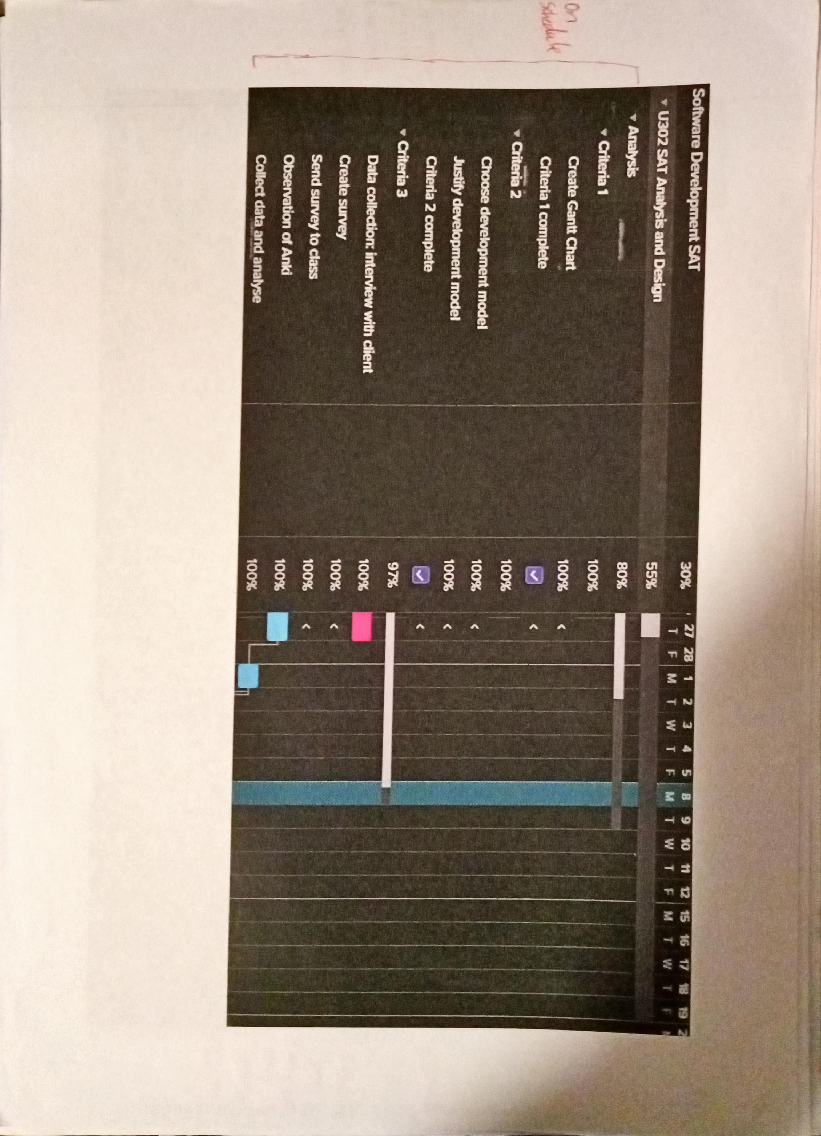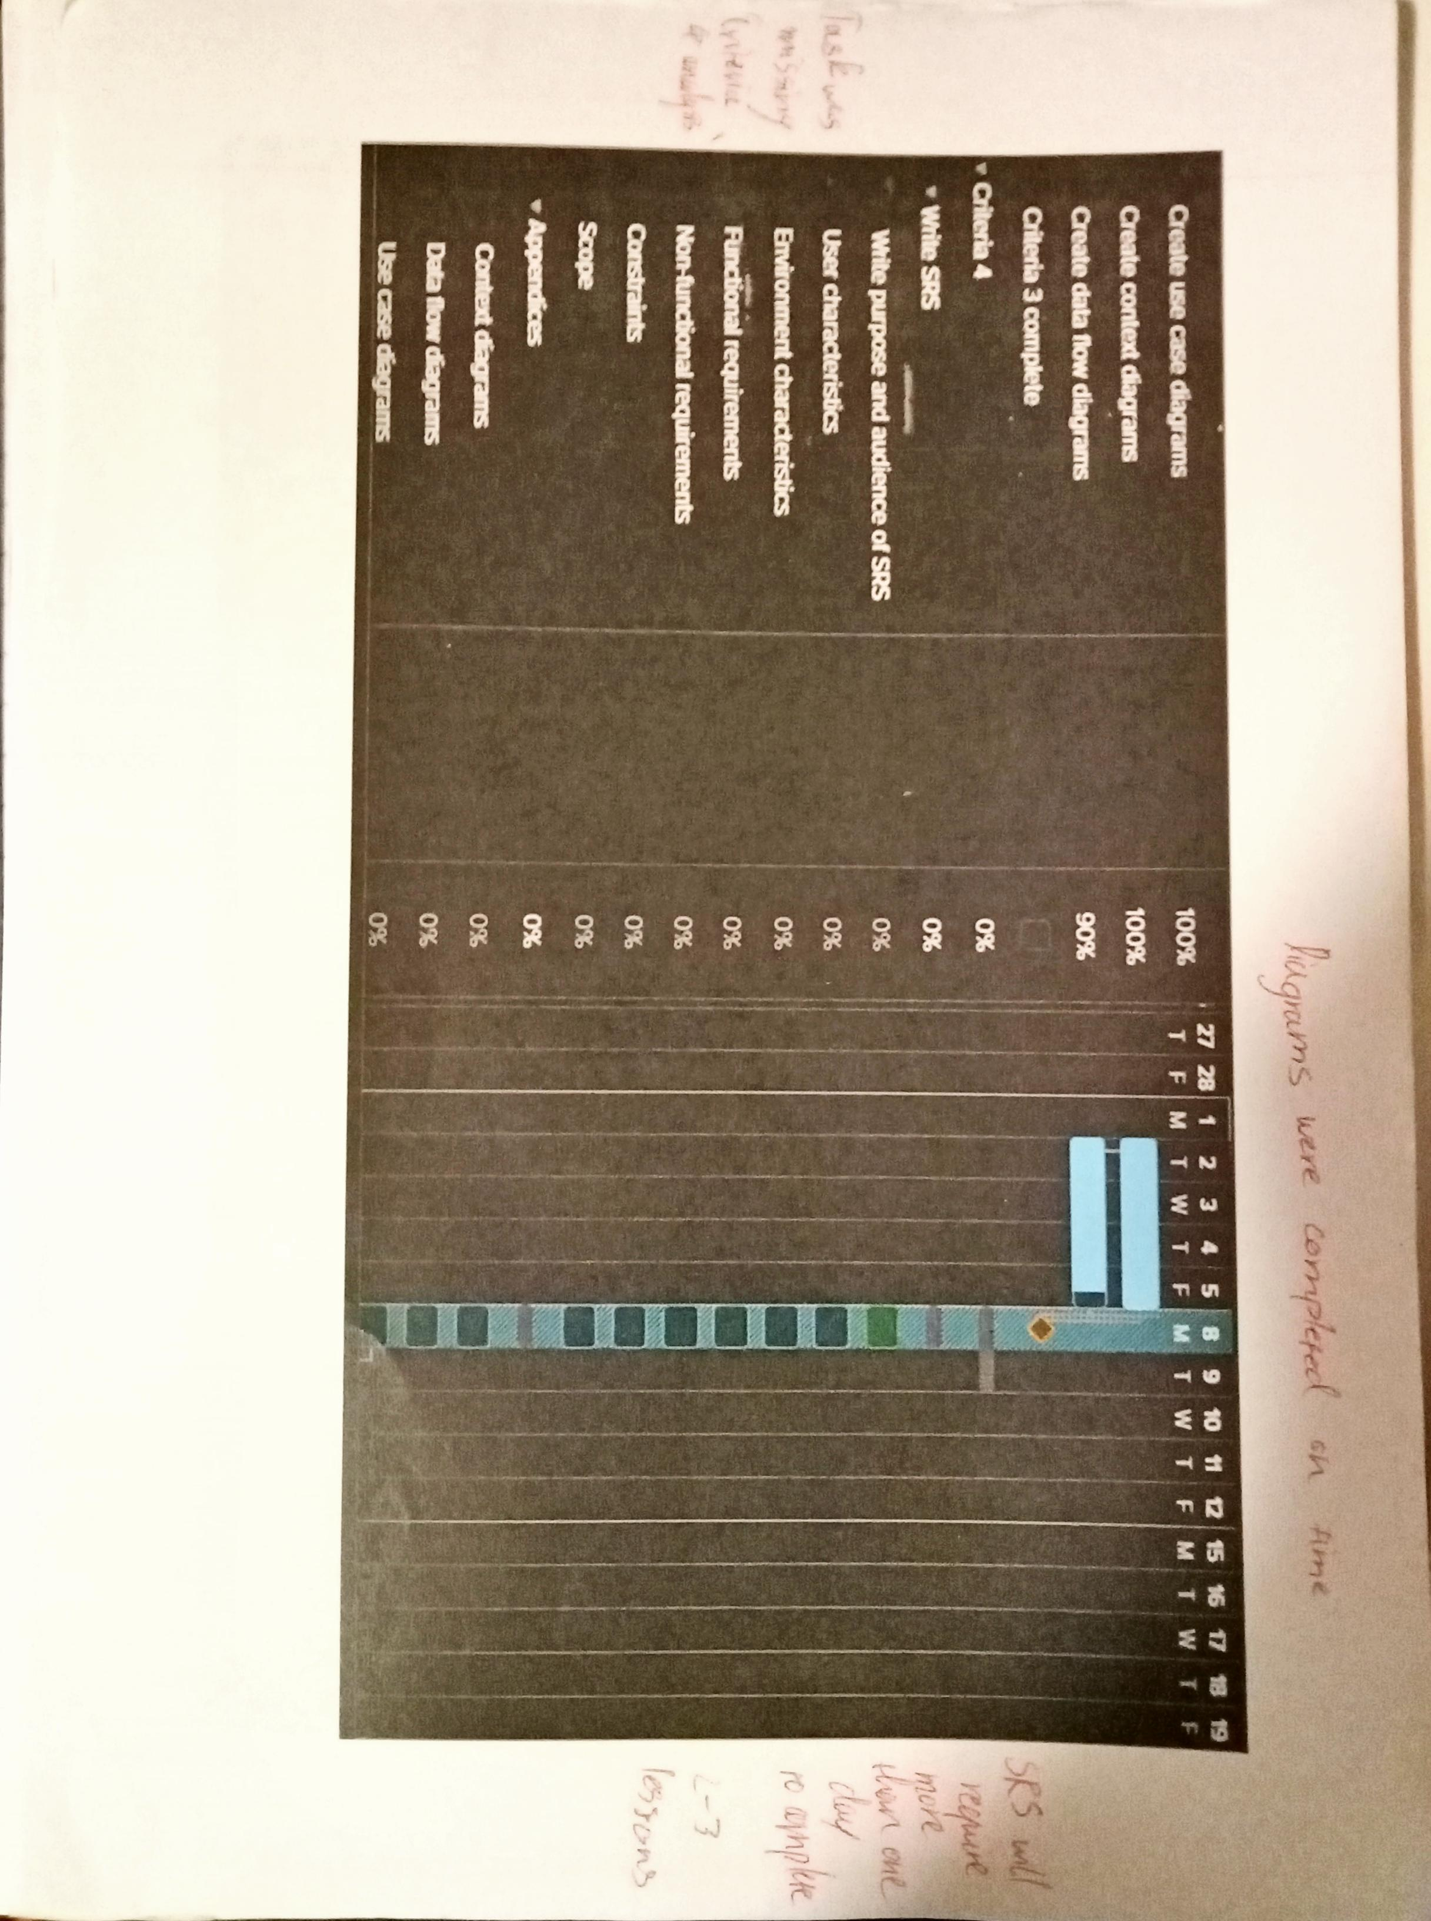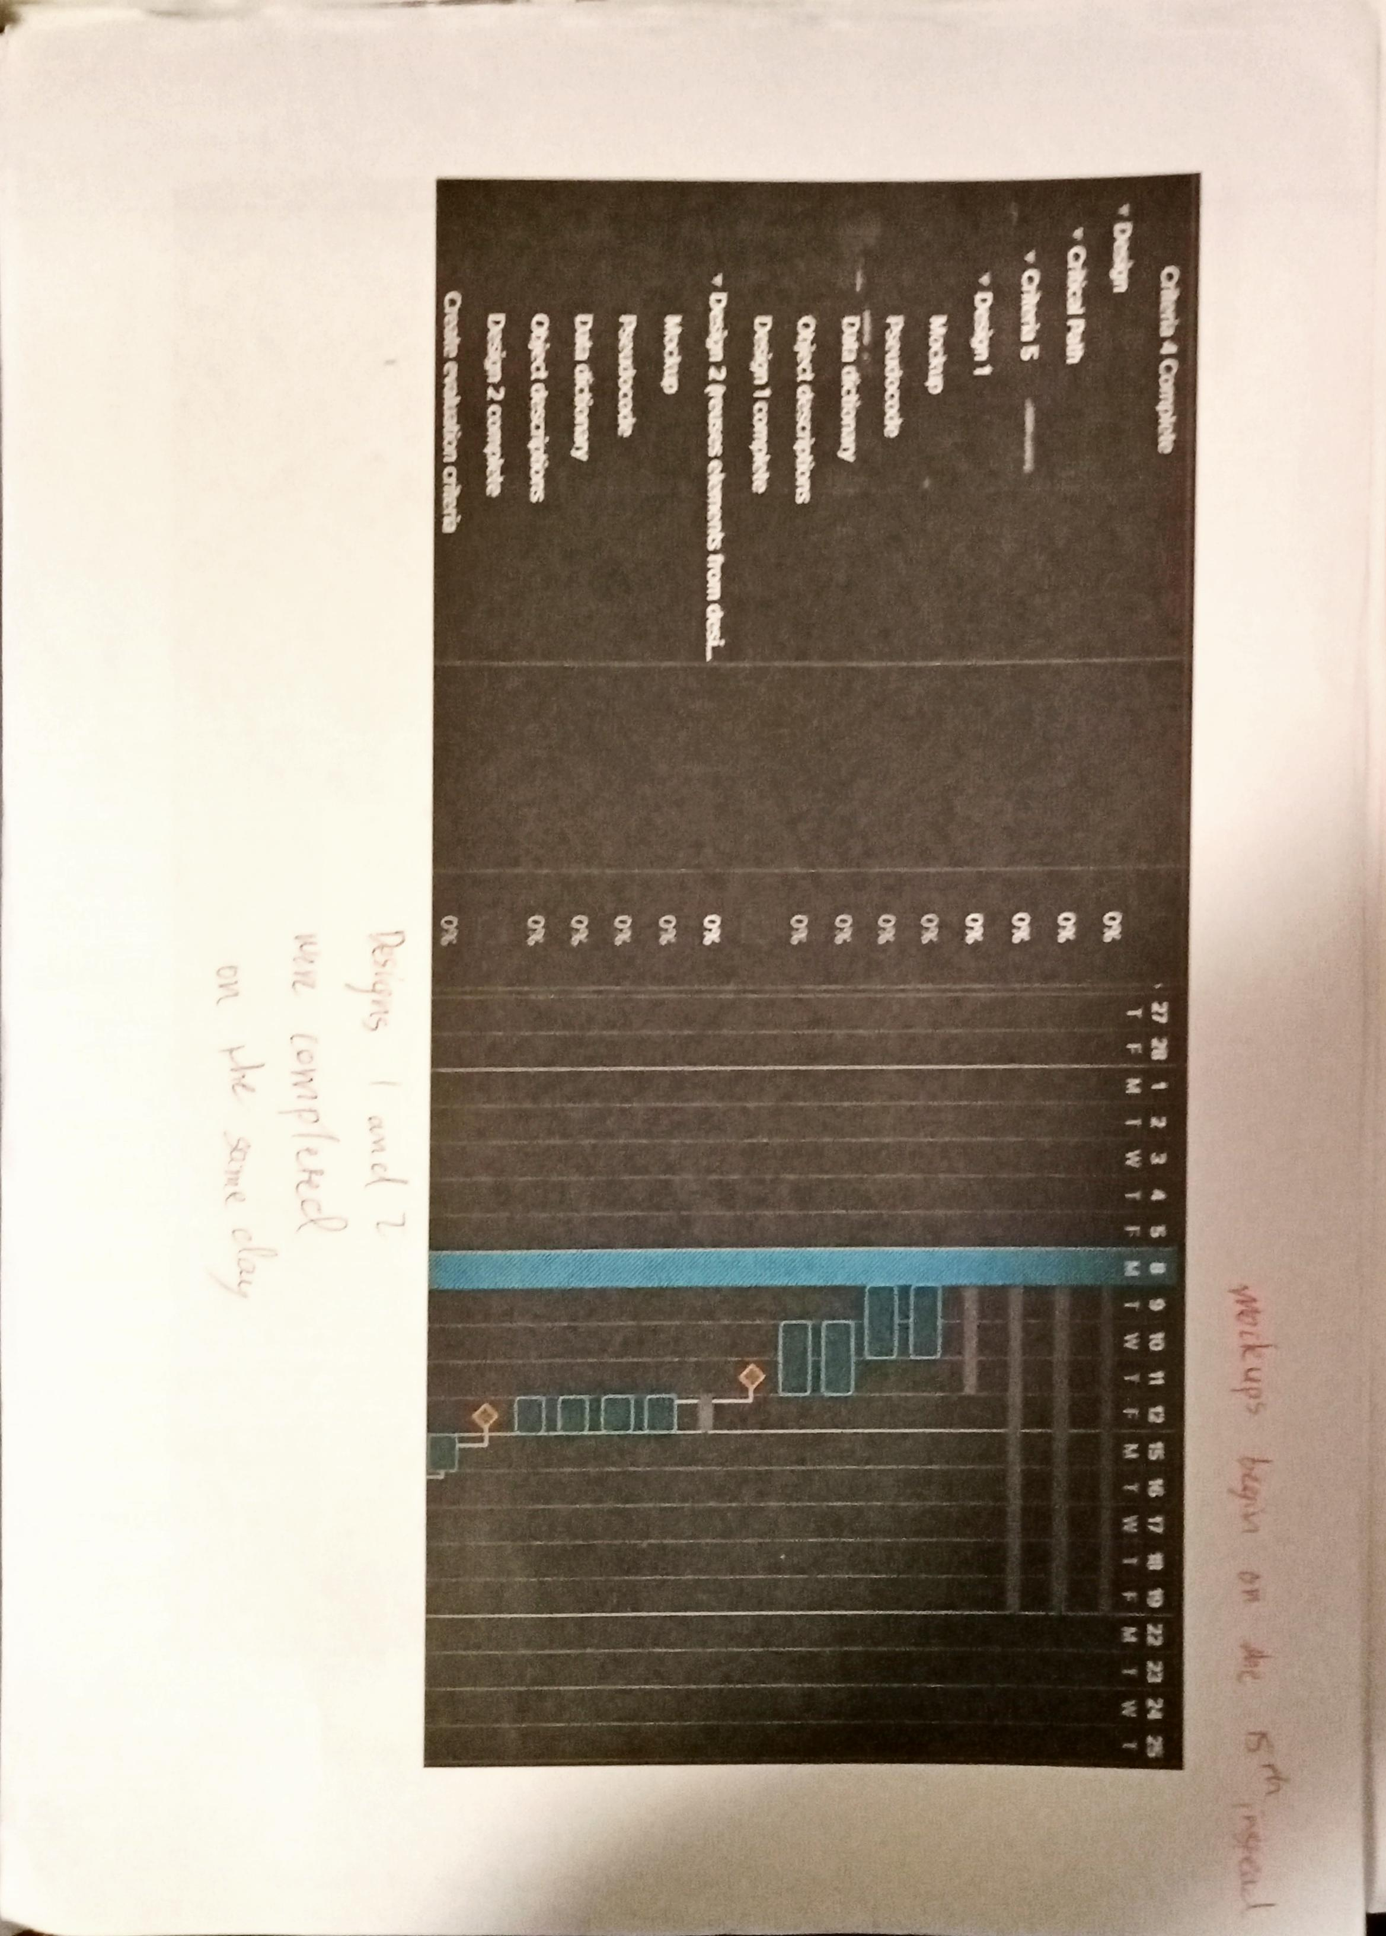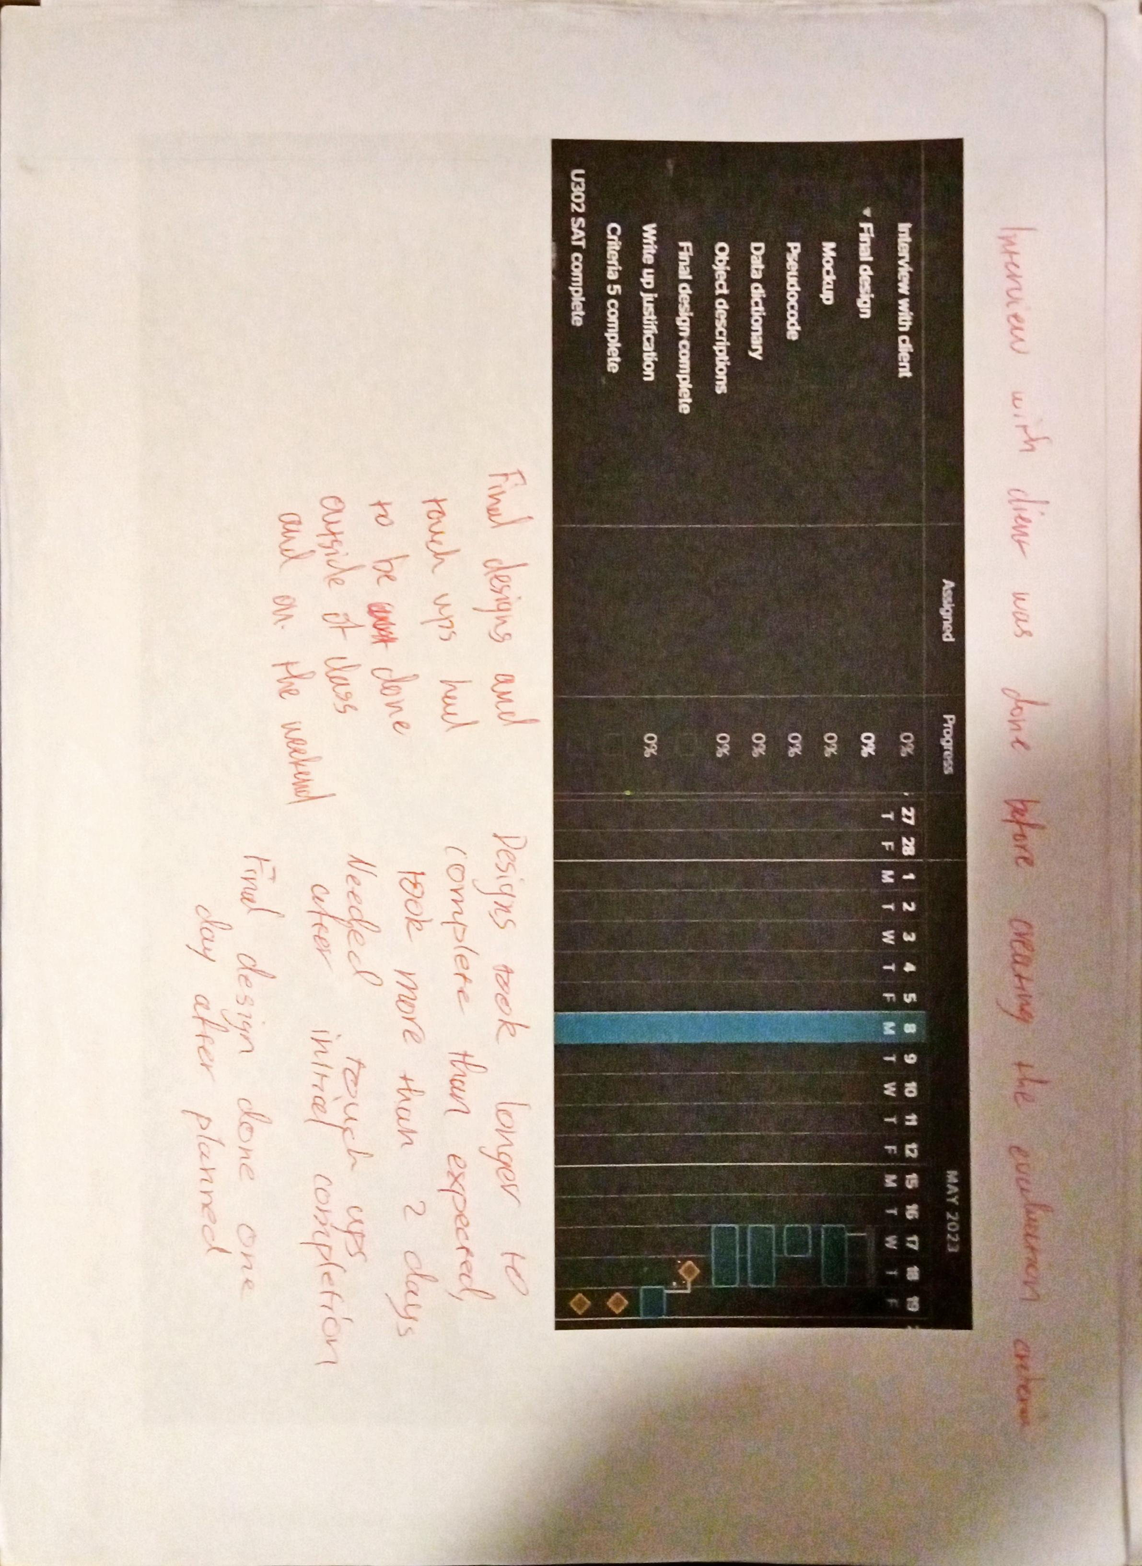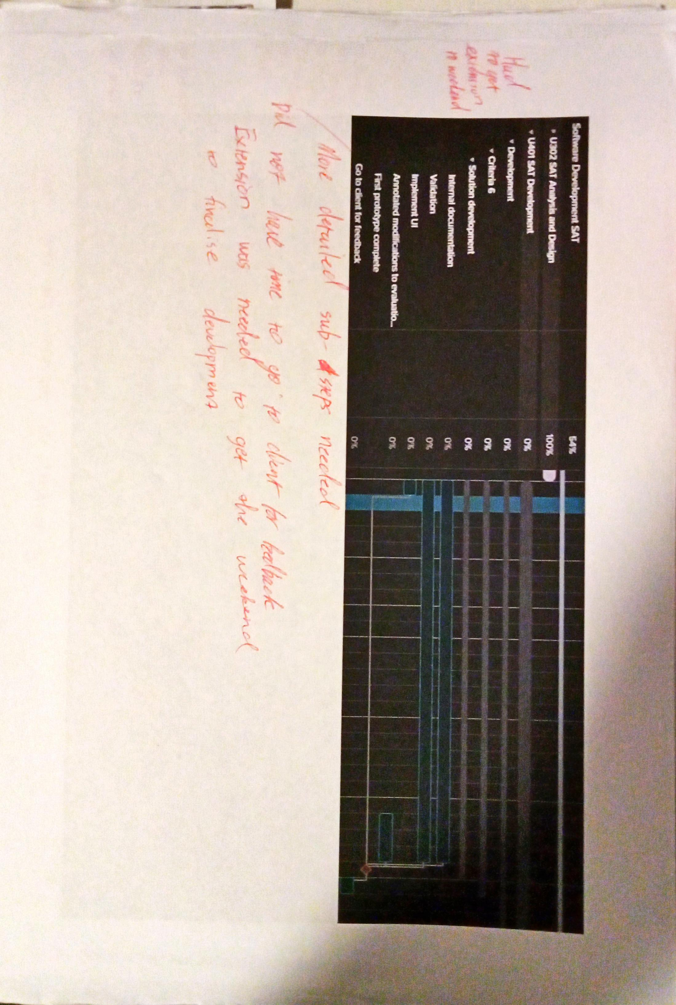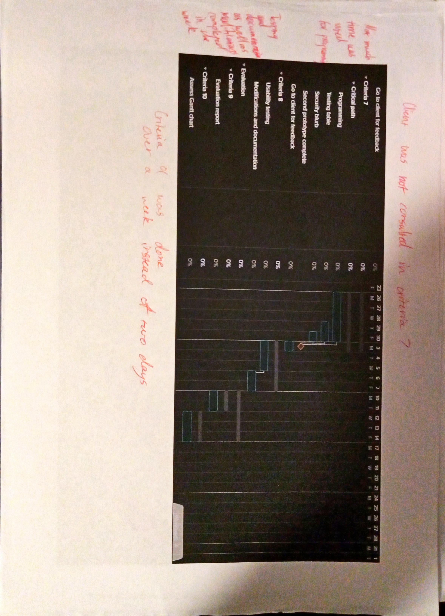

**Logbook and evidence**

**31/03**

In today's class I worked on my Gantt chart that will be used for criteria 1. I made some modifications to take into account that I can work on data collection outside of class time, so I added it to the holiday period. I completed planning out the criteria for the first part of the SAT and started on the second part, starting with criteria 6.

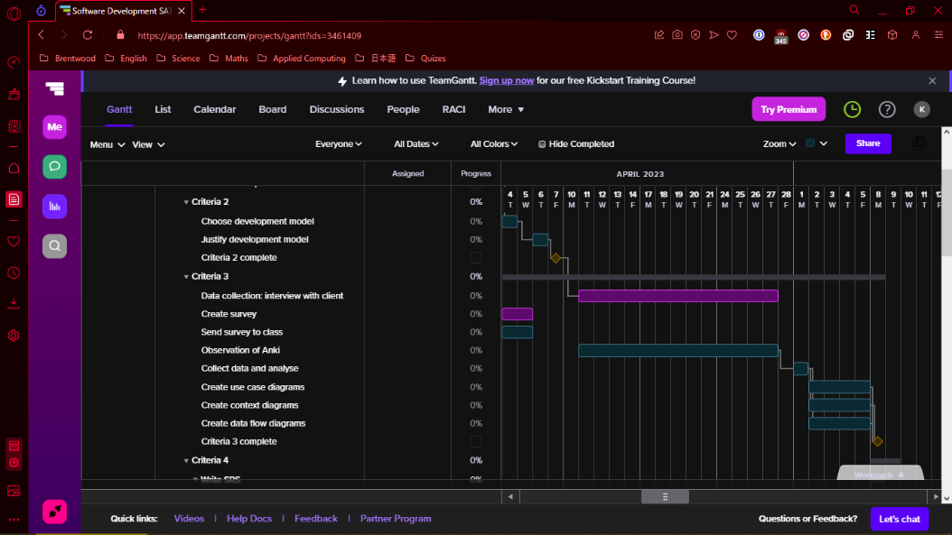

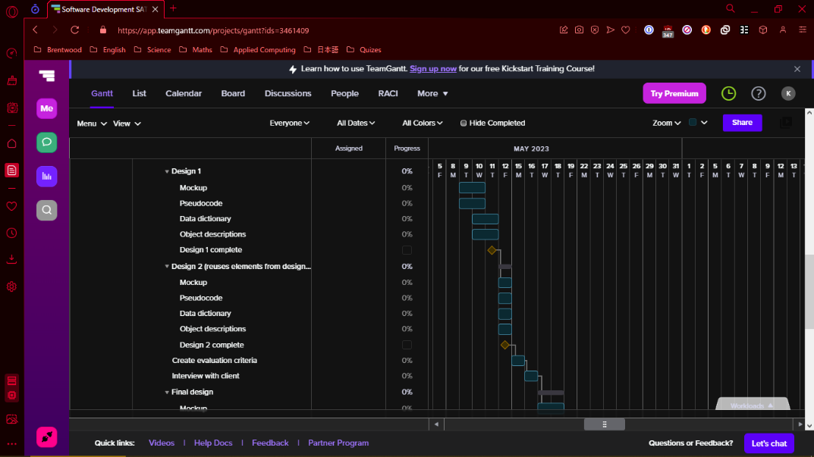

**3/04**

Due to a fire drill during this lesson, not much work could be done. With the time I had, I added the subgroups and tasks for criteria 6-10.

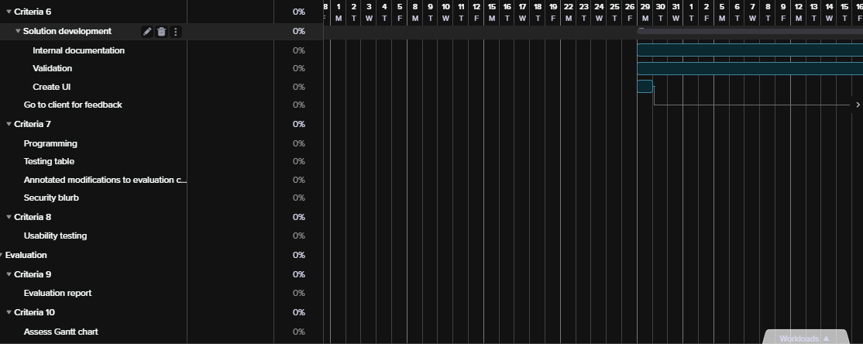

**4/04**

During this lesson I completed the Gantt chart and started the write up for criteria 2. The Gantt chart now has tasks for criteria 6-10 and has all been assigned dates, however these are subject to change as the dates and tasks surrounding the second SAT have not been finalised.

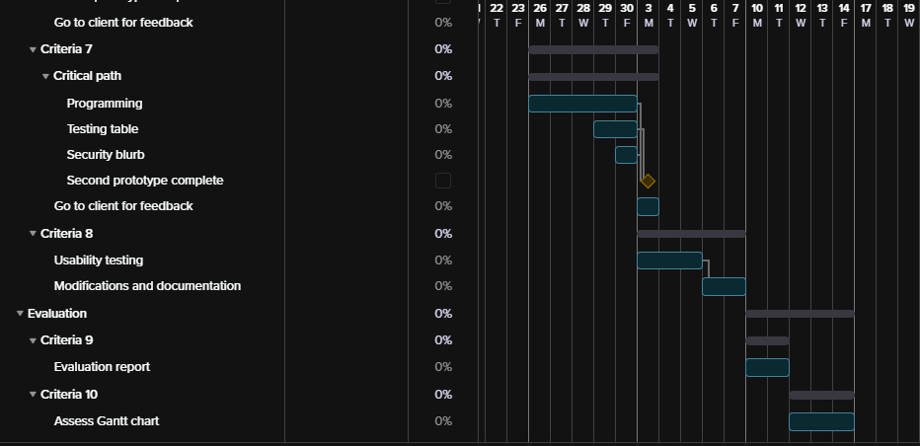

The write up for criteria 2 was started this lesson. I got a start on documenting the waterfall development model, its features and how it works. Next lesson I will be finishing that part off and then moving onto comparing it to the other development models and the justification behind why I chose the waterfall development model.

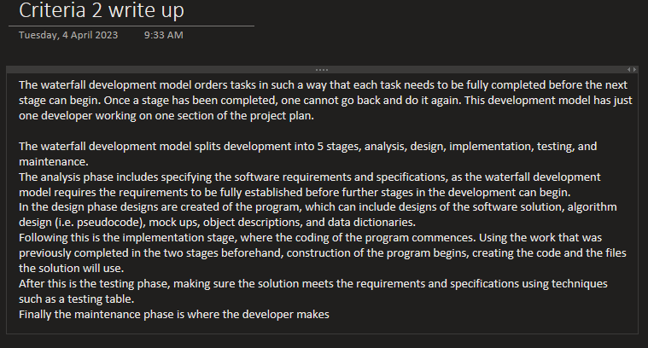

**6/04**

In today's lesson both Criteria 1 and 2 were due for submission, so I completed the two tasks and submitted them as a PDF onto Compass, whilst also signing off on authentication for each of the tasks. The Gantt chart was already complete so I just had to take screenshots of all of its components so it could be submitted. I had a start on Criteria 2 already, so I finished it off in this lesson and added justification as to why I chose the development model I had chosen.

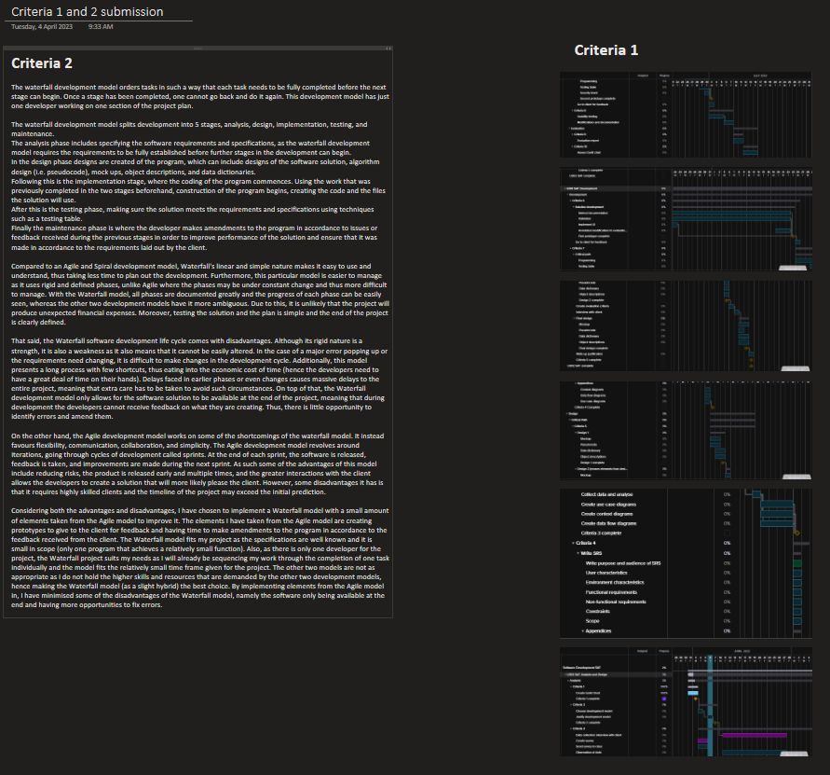

**27/04**

In today's lesson I analysed all of the data that I collected over the holidays, being the interview, survey, and observations. The analysis summarises the information found and lays out a foundation for future elements of the SRS, for example the requirements of the solution.

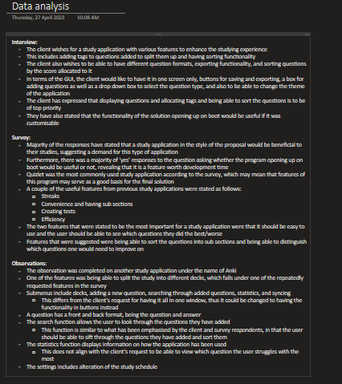

**28/04**

Most of today's lesson was spent learning about use case diagrams so that next lesson I will be able to start working on it straight away. I added screenshots of my survey as part of the evidence for data collection and over the weekend I will finalise the functional requirements to be ready to create the use case diagram.

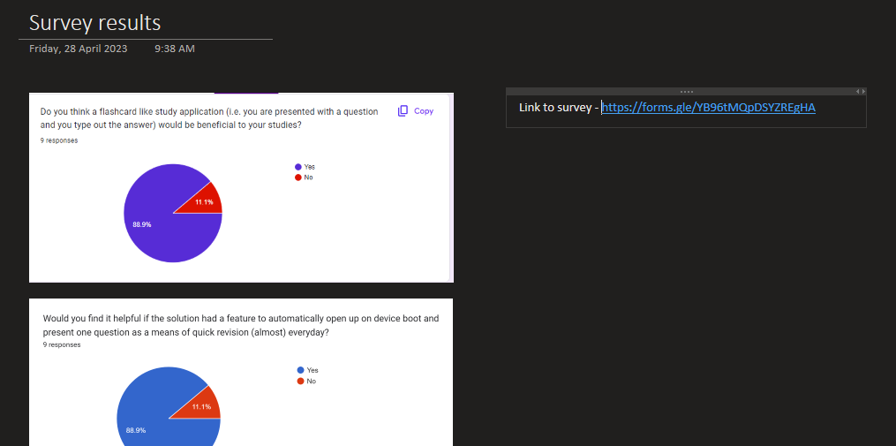

**1/05**

In today's class I submitted my data collection and started on the diagrams for criteria 3. I completed the use case diagram and got started on the context diagram. Next lesson I plan on finishing the context diagram and starting on the data flow diagram.

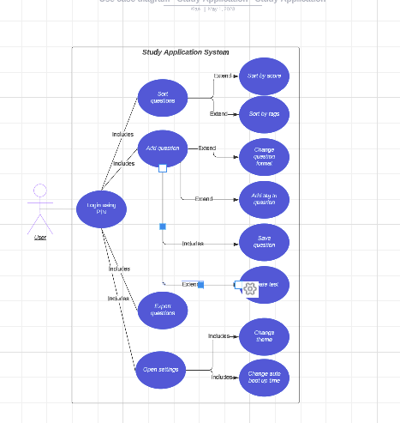

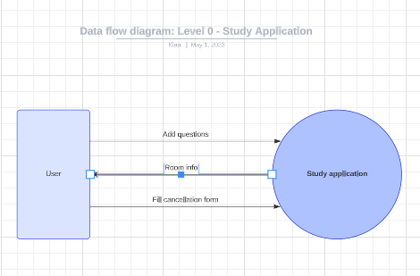

**3/05**

Today I did some work outside of class due to missing out on a class yesterday. I completed the context diagram and next I will be moving onto completing the data flow diagram.

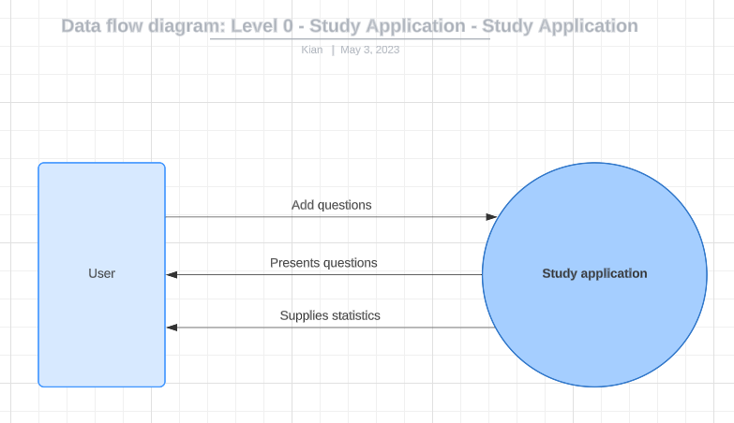

**4/05**

In today's period I begun work on the SRS, setting up the format and starting on the requirements and purpose section of the document.

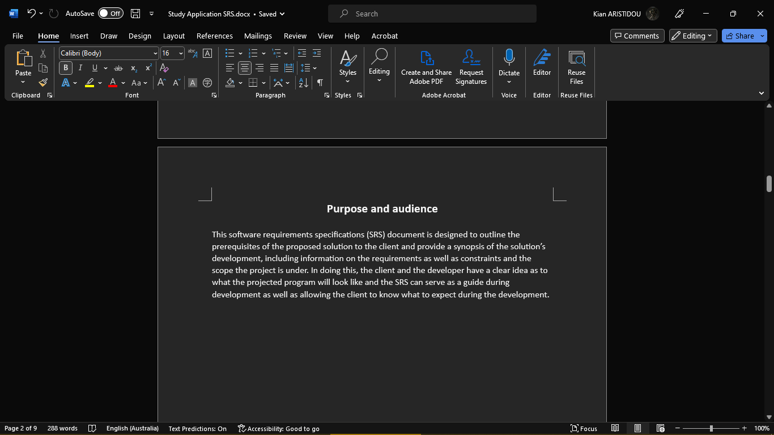

**5/05**

The class today was spent learning theory for a data flow diagram, the rules and how to draw one. Thus, no work was done on the SAT.

**8/05**

Today was spent creating the DFD for the study application. It is mostly complete but may need some touching up in the future. Next lesson will be dedicated to working on the SRS.

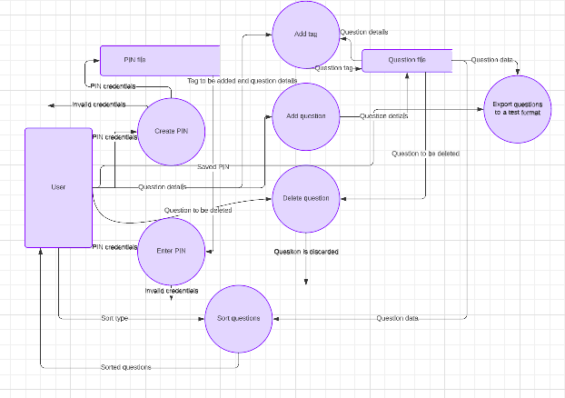

**9/05**

In today's lesson more work on the SRS was done, with most of it complete. Touching up on the DFD needs to be done and proofreading of the SRS will be done in a future lesson.

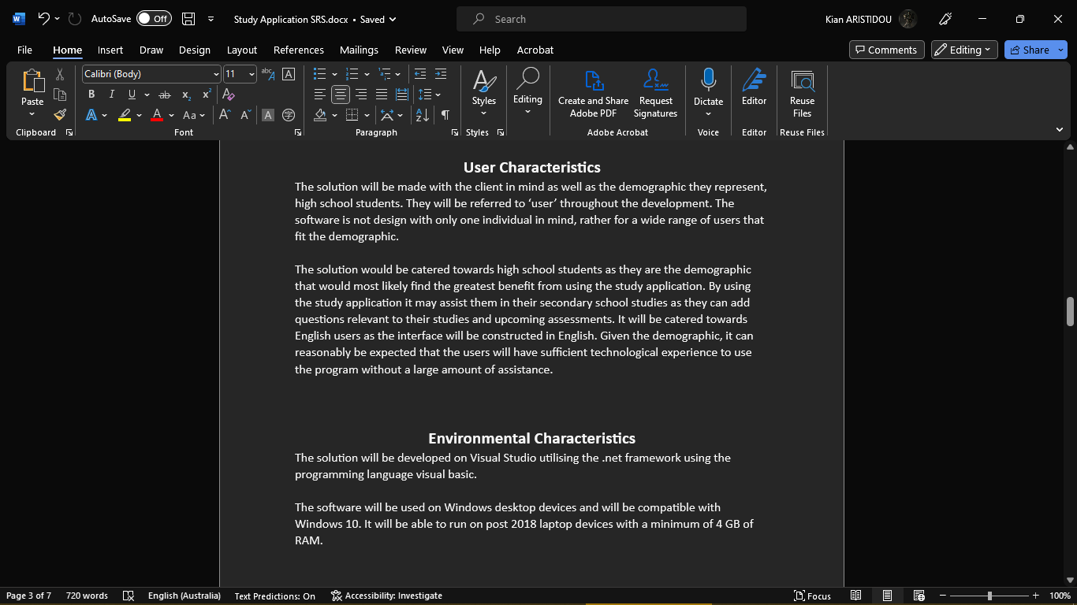

**11/05**

Today I touched up on the DFD and completed the SRS. All aspects of the SRS are complete and next lesson will have some time spent on proofreading it for submission.

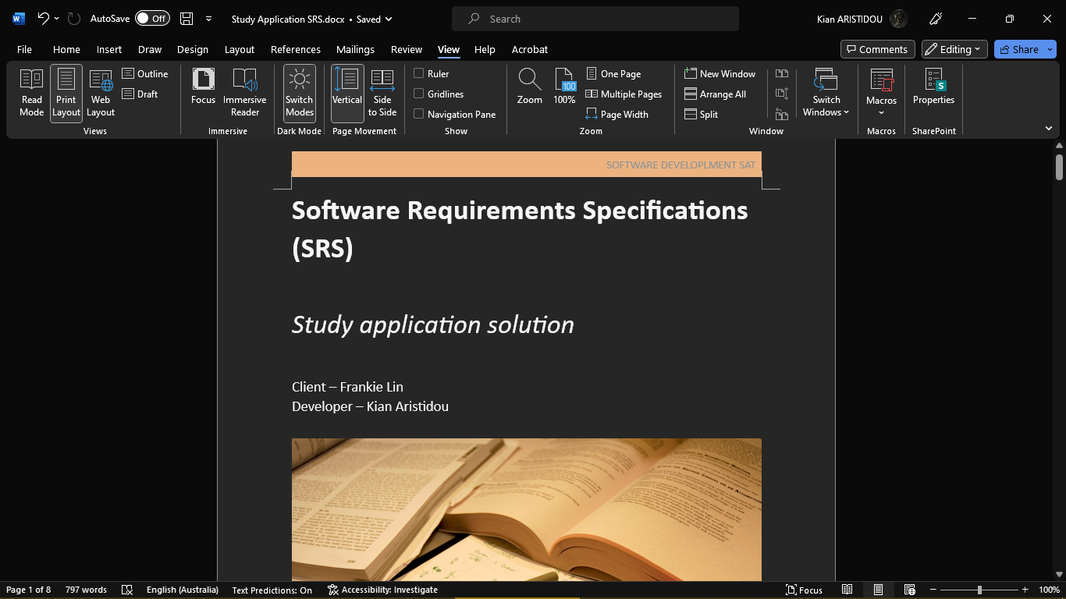

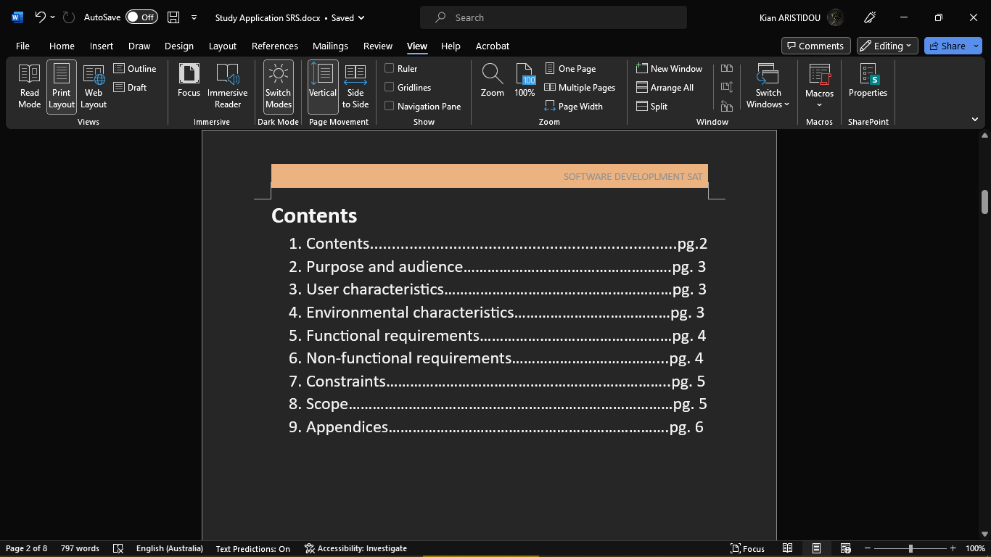

**12/05**

Criteria 3 and 4 were completed for submission and uploaded. The lesson was spent writing the analysis for criteria 4, criteria 3's analysis was already completed beforehand.

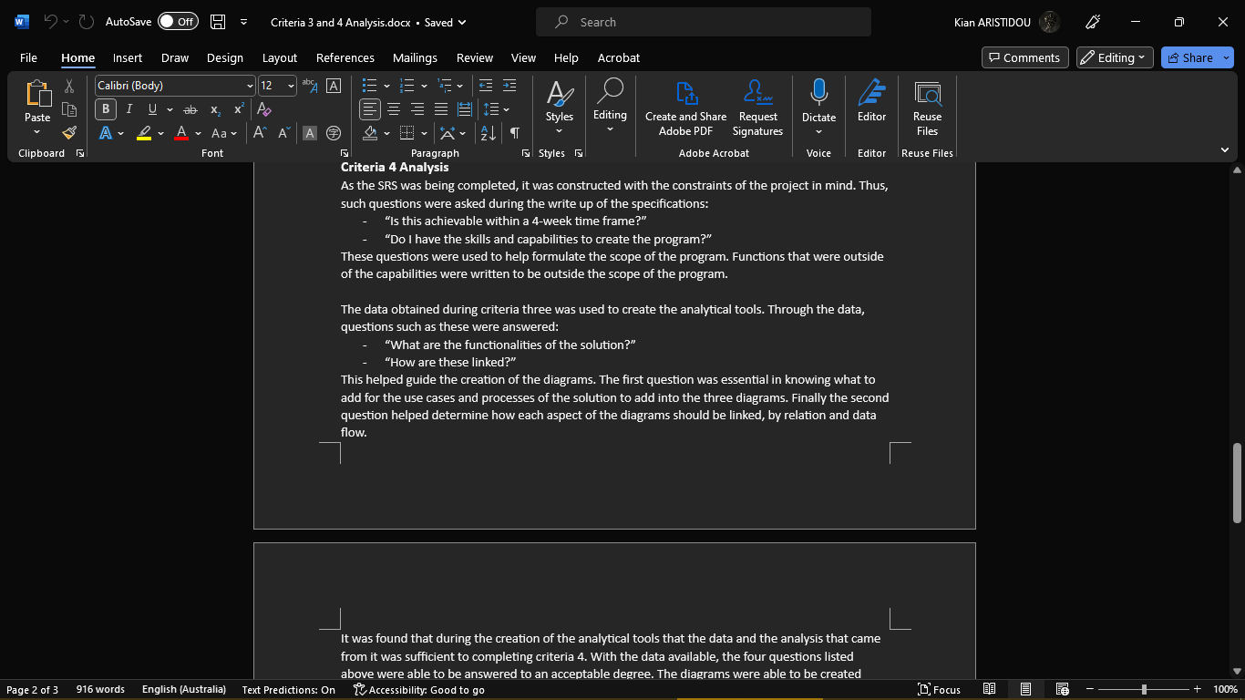

**15/05**

The mock-ups for designs 1 and 2 were started today, with design 1 being complete and design 2 almost complete. What will follow will be the other aspects of the design including data dictionaries and etc.

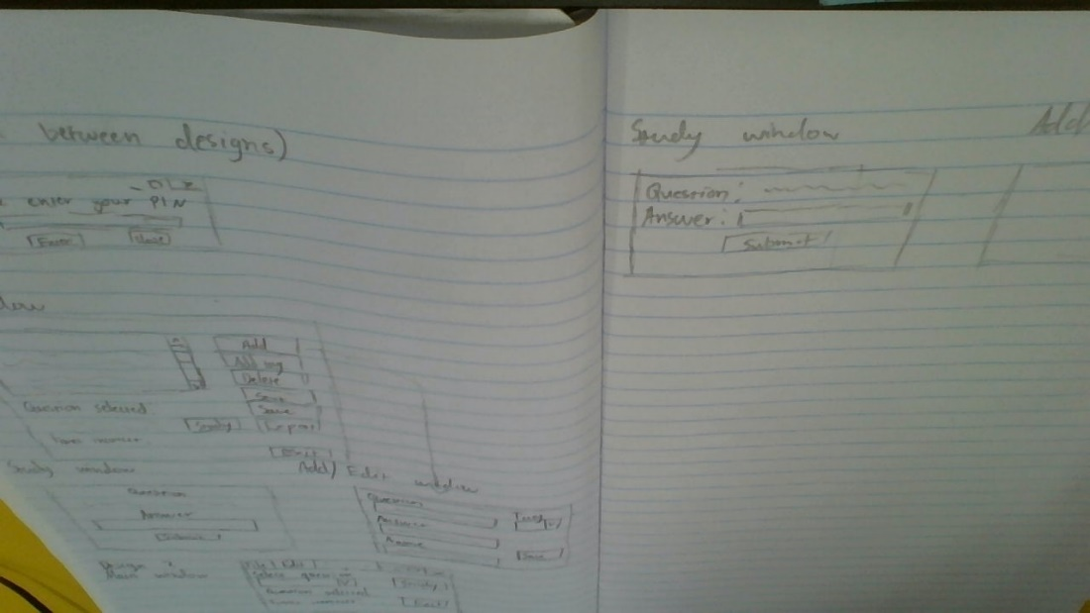

**16/05**

The work was done outside of class during this period. Time was spent adding annotations to the mock ups. What will follow are the other pieces of the design, including data dictionaries and pseudocode.

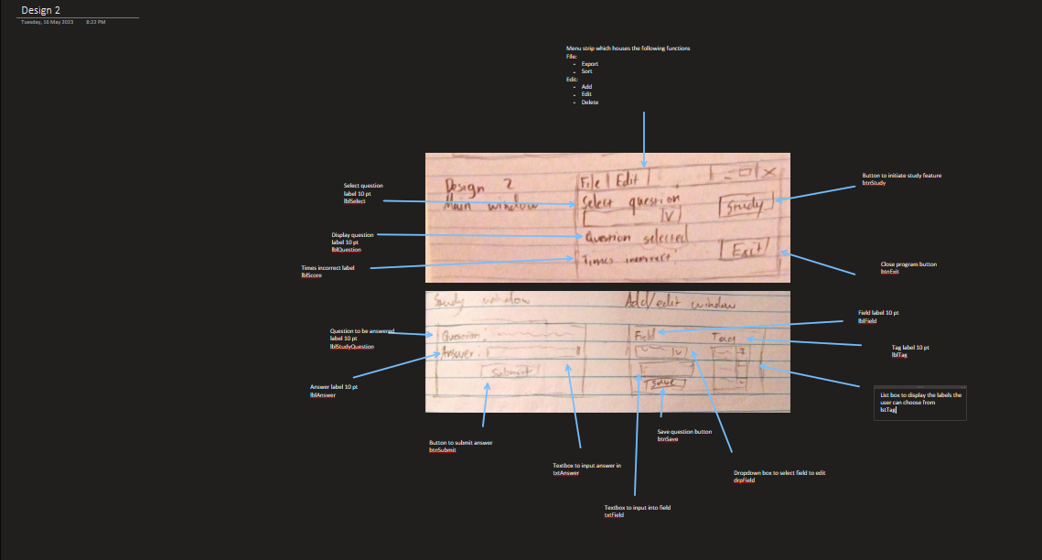

**17/05**

The progress made today was done outside of class. I worked on completing the two designs. What needs to be done next is an interview with the client to finalise the final design, and finally complete the evaluation criteria.

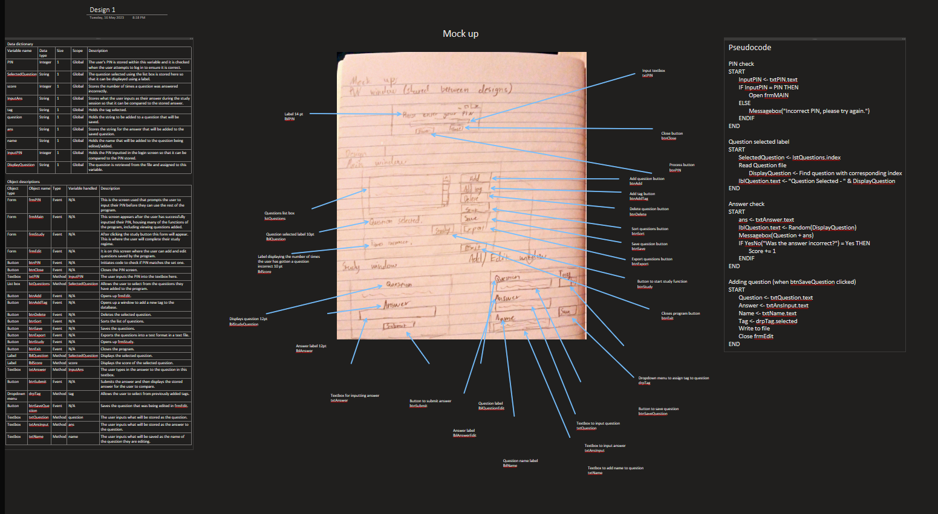

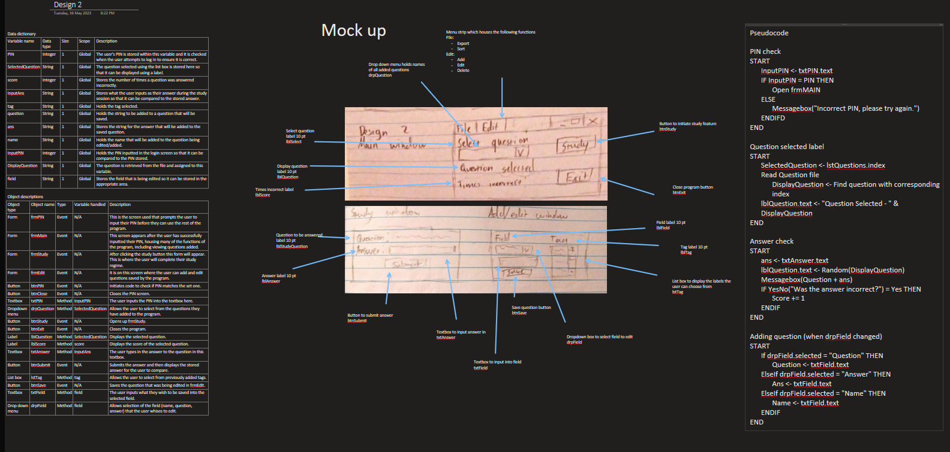

**18/05**

In class the evaluation criteria was worked on and feedback was received (including an interview with the client) on the first two designs so I know what I need to touch up on before submission. I received an extension so that it is due on Monday so I can have more time to touch up on everything I have done.

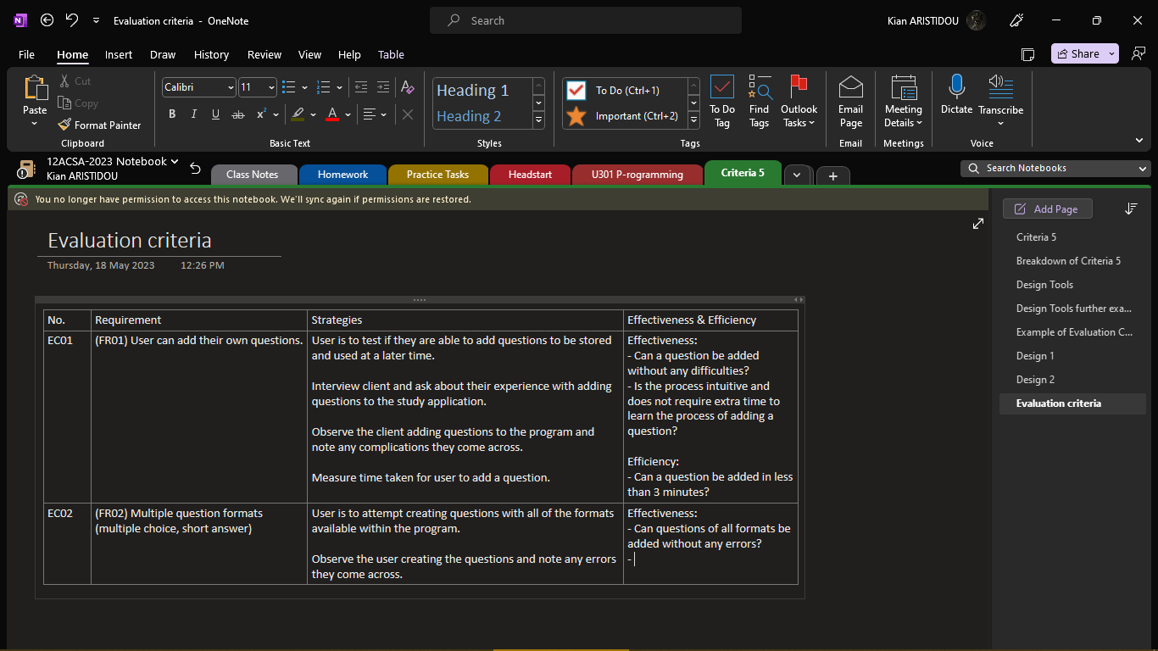

**19/05**

In class: The mock-up for the final design was completed.

Outside of class: The final design was completed, including the other elements of the design.

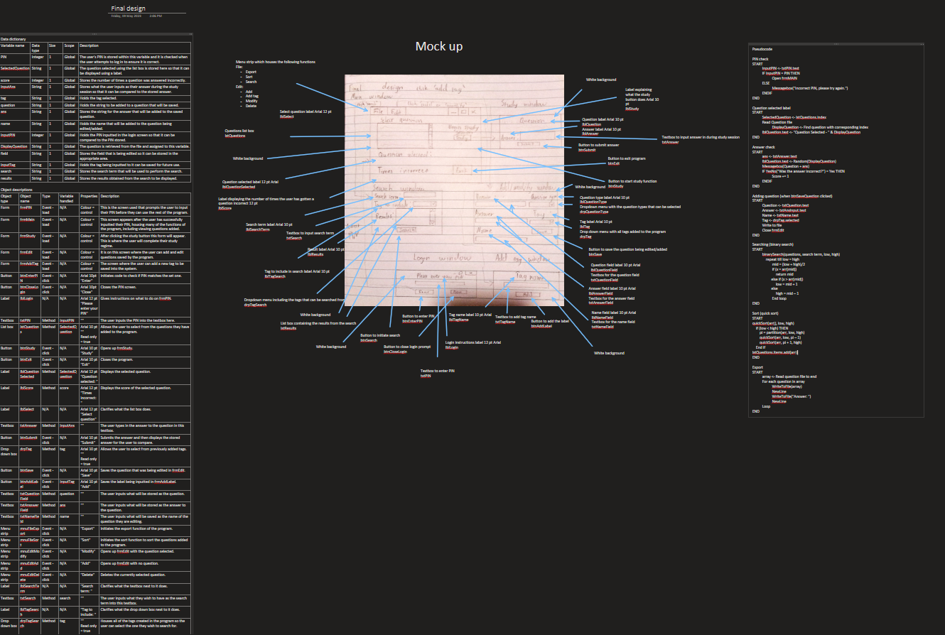

**20/05**

Outside of class: touch ups on the previous designs were done, cleaning up the mock ups and making edits to the other elements of the designs. It was then submitted for criteria 5.

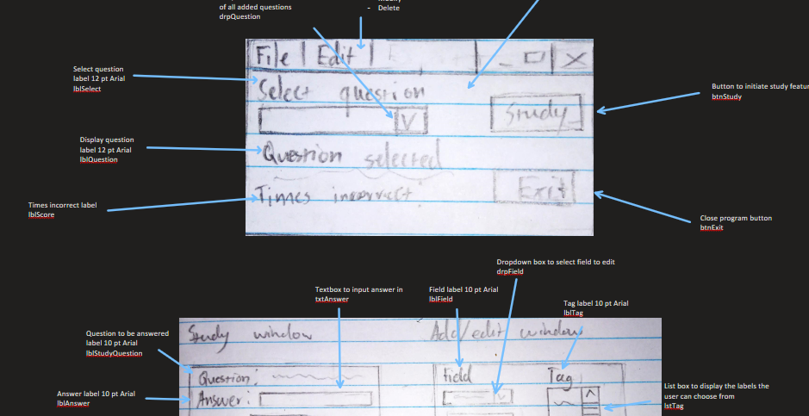

**22/05**

The SAT was printed out in its entirety and handed in. The project file for the SAT was created.

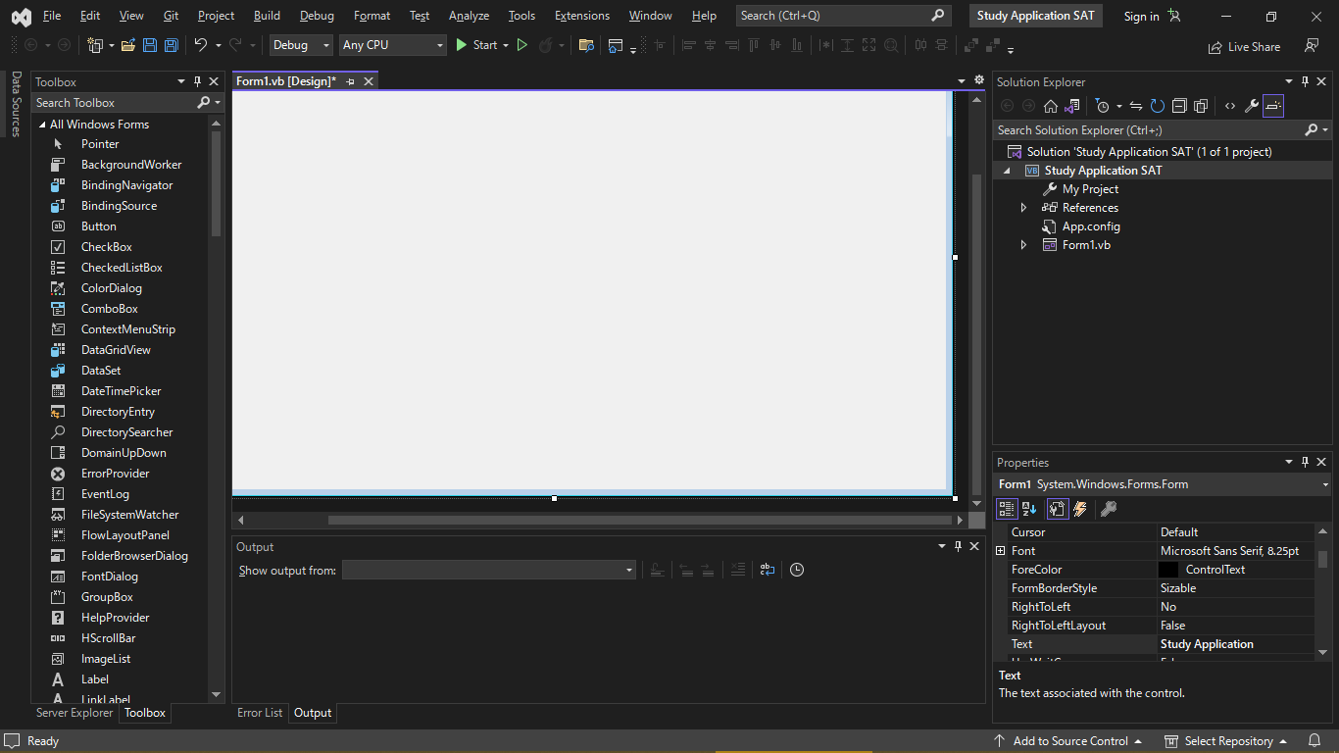

**23/05**

The Gantt chart for criteria 6-10 were printed and more work on the UI on the program was done.

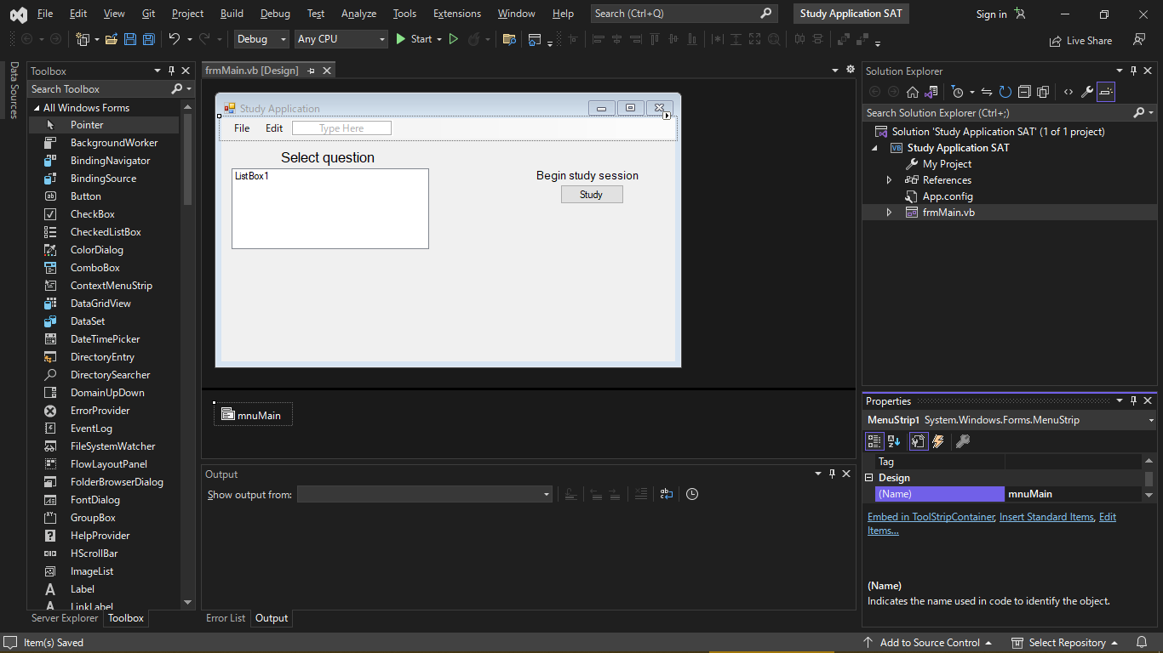

Outside of class, the Git Hub repository for the program was set up so the SAT can be worked on with multiple devices.

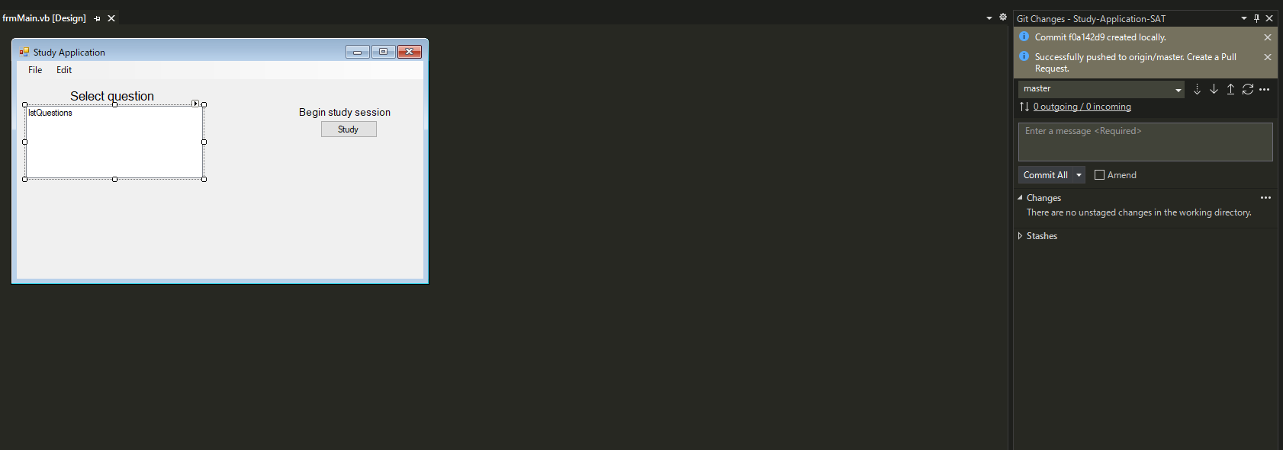

**25/05**

Most of the lesson was spent doing exam revision so there was little time to work on the SAT.

**26/05**

More work on the UI was done and some code for changing forms was added.

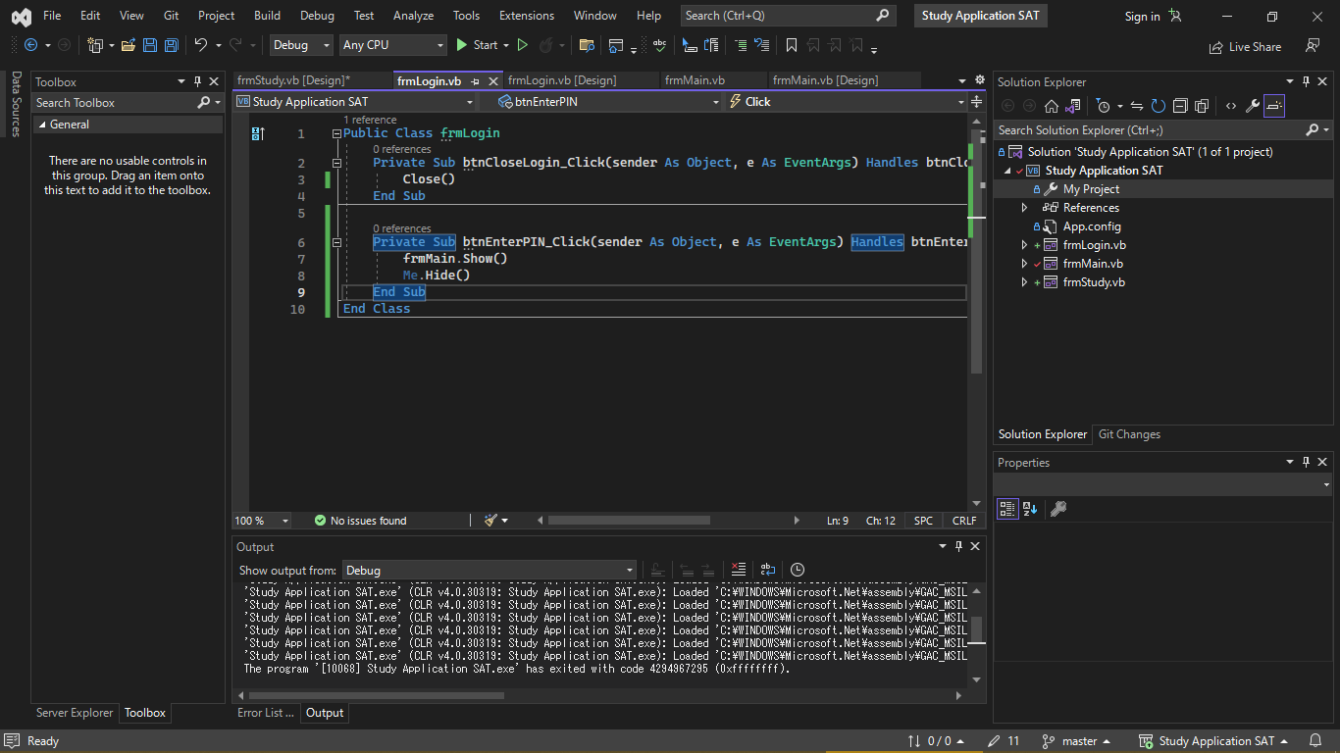

**28/05**

The UI for each form was completed with some code added to switch between the forms.

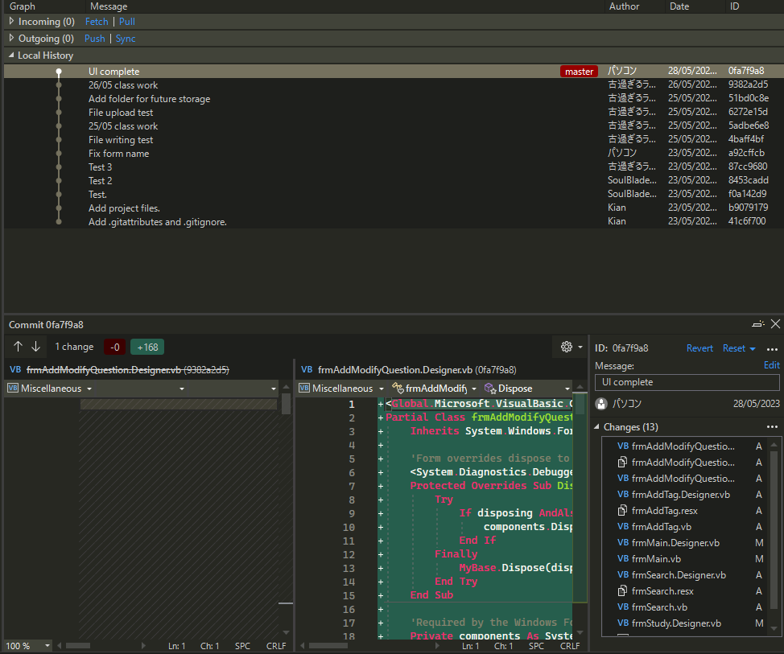

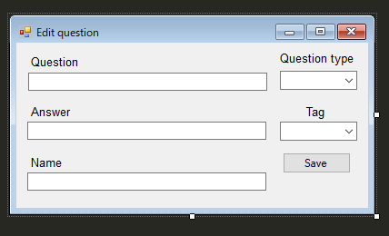

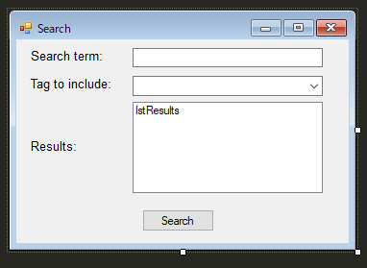

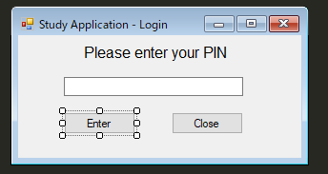

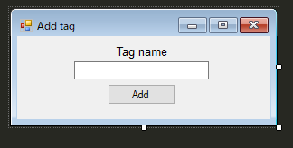

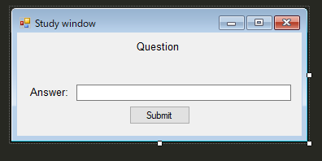

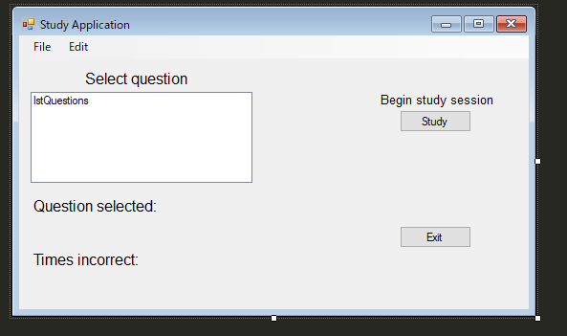

**29/05**

More code was added to switch between the forms and a test function for the login window was implemented.

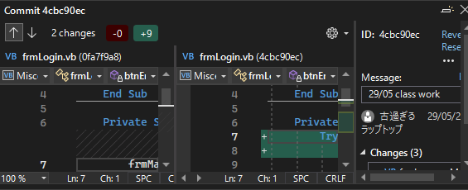

**30/05**

The login functionality was added to the application.

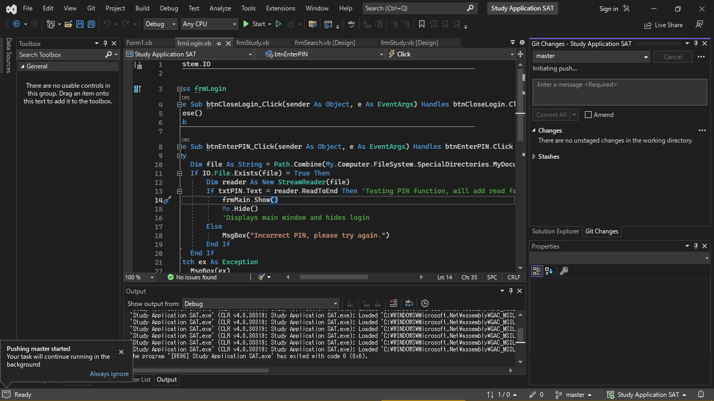

**31/05**

Some validation was added to the PIN creation process and the functionality to create tags was added.

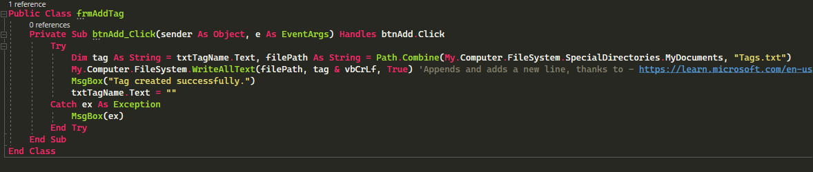

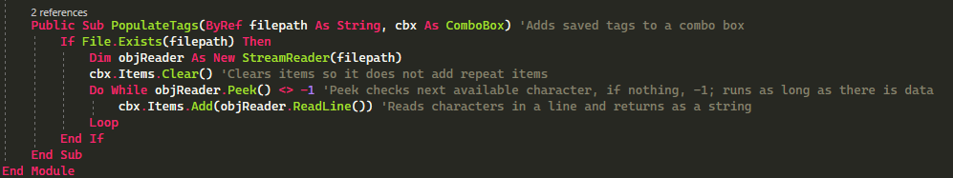

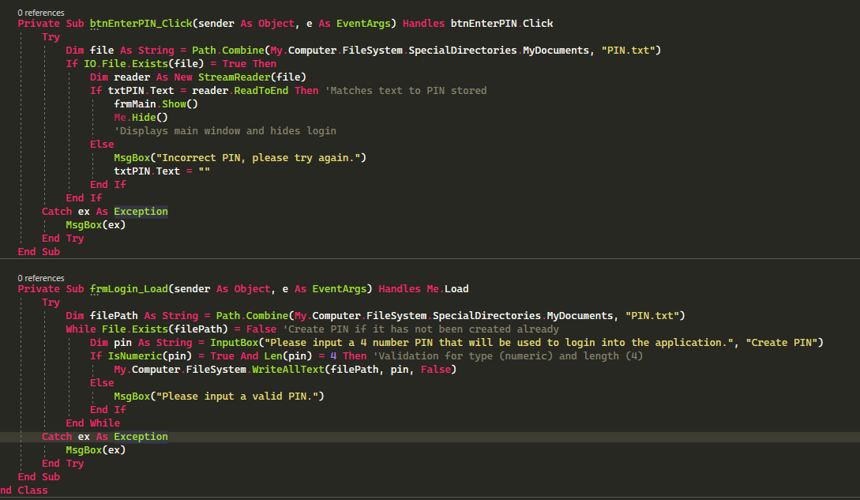

**1/06**

Added more internal documentation and created a Boolean which modifies the add/modify question window depending on which menu strip was clicked.

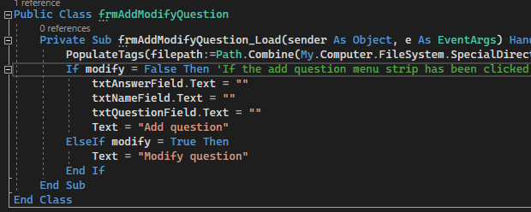

**2/06**

Most of the lesson was spent on doing short answer practice for the exam. In terms of the SAT a new icon was added, sourced from - <https://www.pngkey.com/download/u2w7o0q8i1q8t4t4_study-flat-icon/>

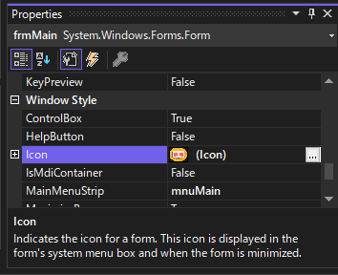

**4/06**

The function to write question files was added.

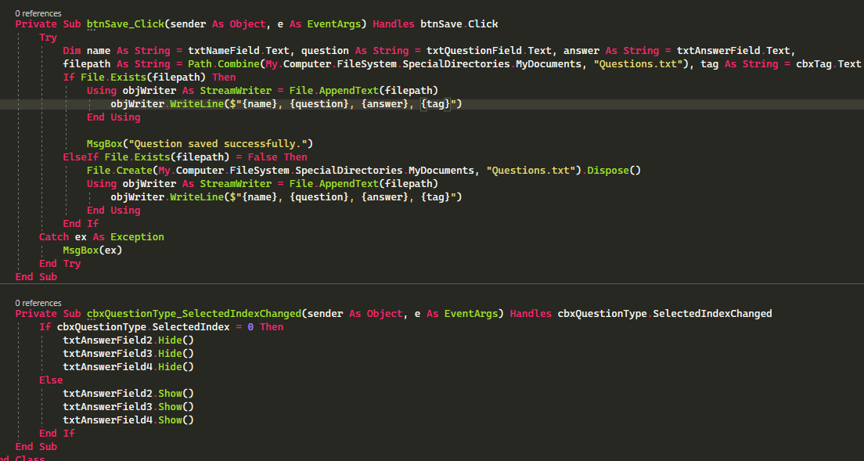

**5/06**

The code to write to files was altered to add functionality for creating multiple choice questions.

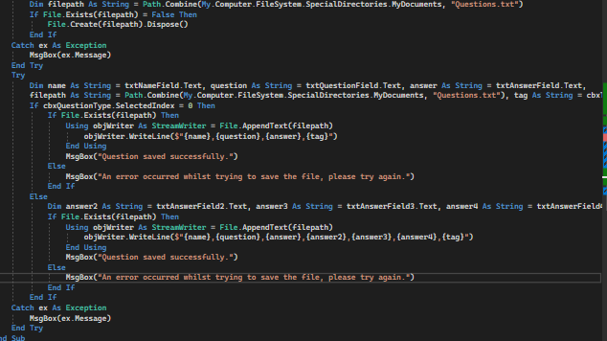

**6/06**

Some code was added to create an array from the generated CSV file but currently it does not work and needs more time to work on it.

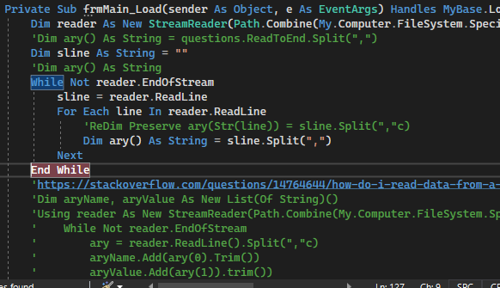

**8/06**

Some code for adding the CSV to an array was modified, however it still needs more work.

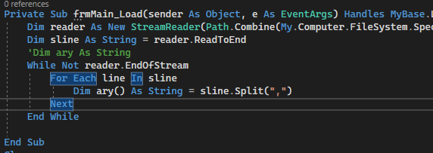

Icons were added to some forms as well.

**9/06**

2/7 of the required functionalities are completed. Code for a linear search was added in case it needs to be used in the future and an icon was added to the search window.

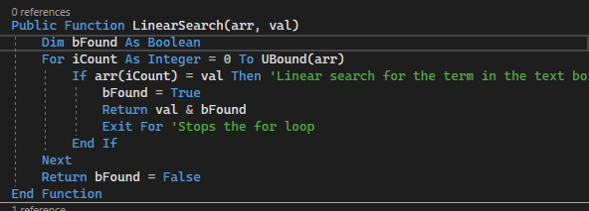

Icon source - <https://icons.iconarchive.com/icons/pelfusion/long-shadow-ios7/1024/Search-icon.png>

**10/06**

Added some code for reading the CSV file to display on the home screen. Still requires some work.

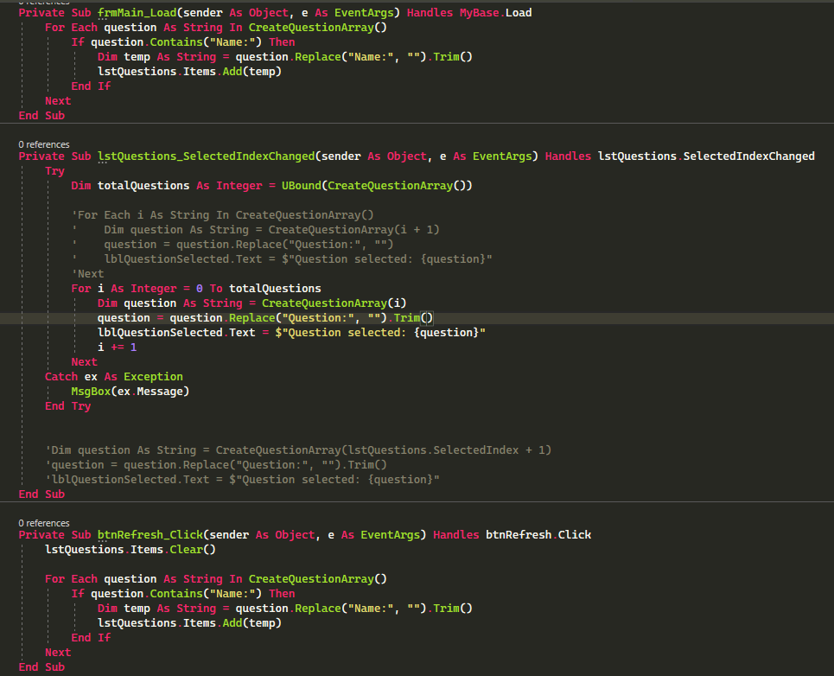

**11/06**

The functionality to read single answer questions in the study feature was completed.

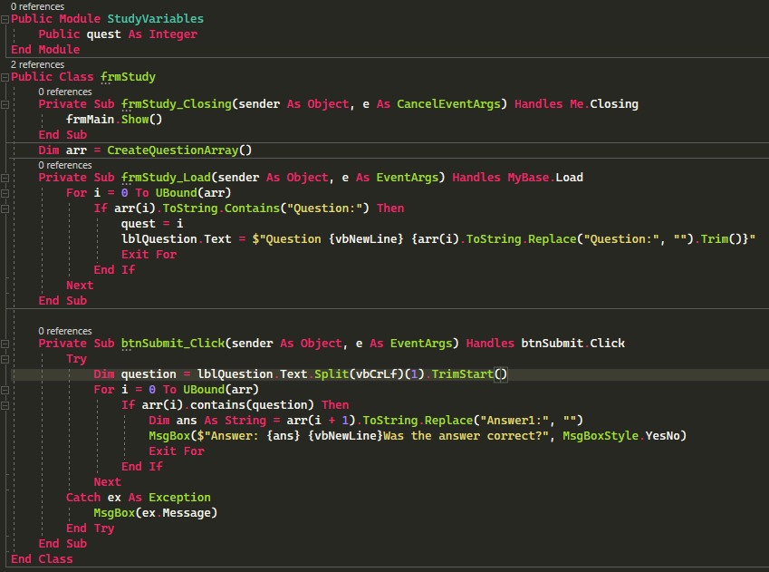

**14/06**

A bit of code was done so that the text from the selected question is auto filled when selecting the modify question window. The edit functionality is yet to be implemented.

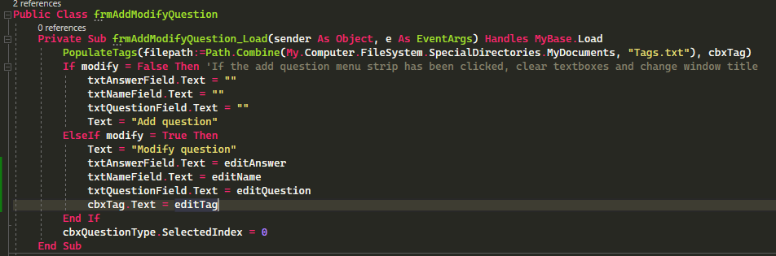

**15/06**

The functionality for sorting and editing was completed, with some progress made on searching and deleting done. However an error unrelated to the code keeps occurring when attempting to test the delete function, so it will have to be tested at another time.

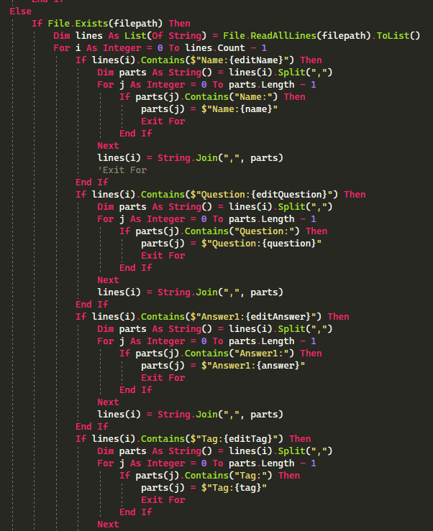

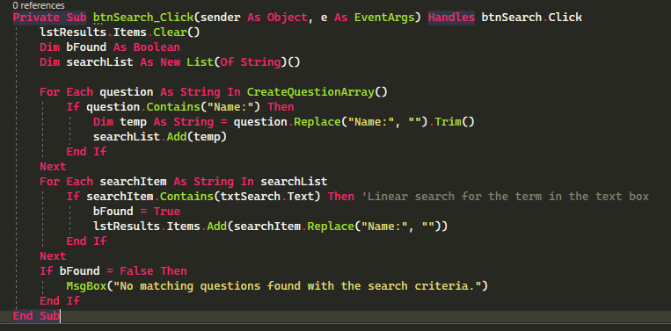

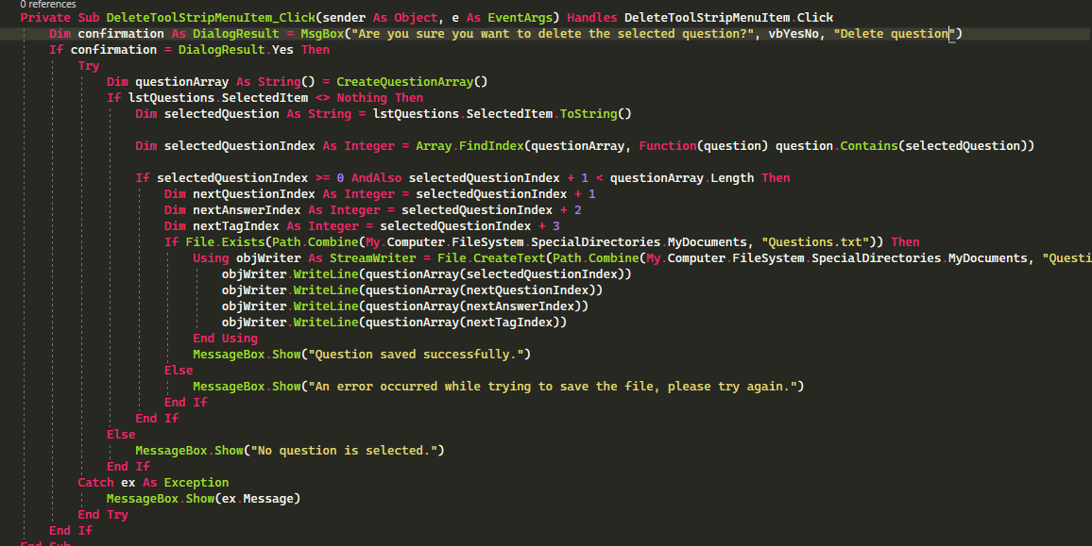

**16/06**

Added some code for increasing the score by 1 when one gets a question incorrect when studying and opening the program up on boot, but both are incomplete.

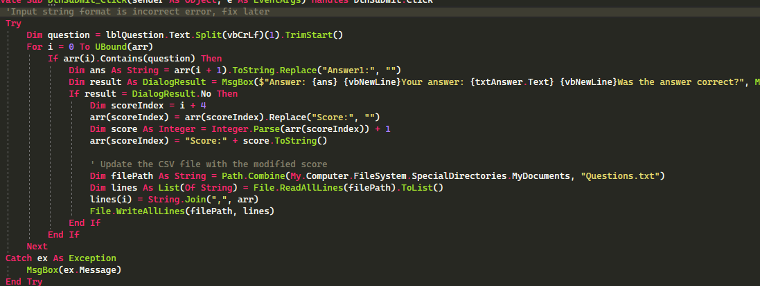

**17/06**

Spent upwards of 4 hours today getting pretty much the rest of the functionalities working to some extent. Remaining work includes getting the scoring system working (but the foundation is done), internal documentation, and justifications.

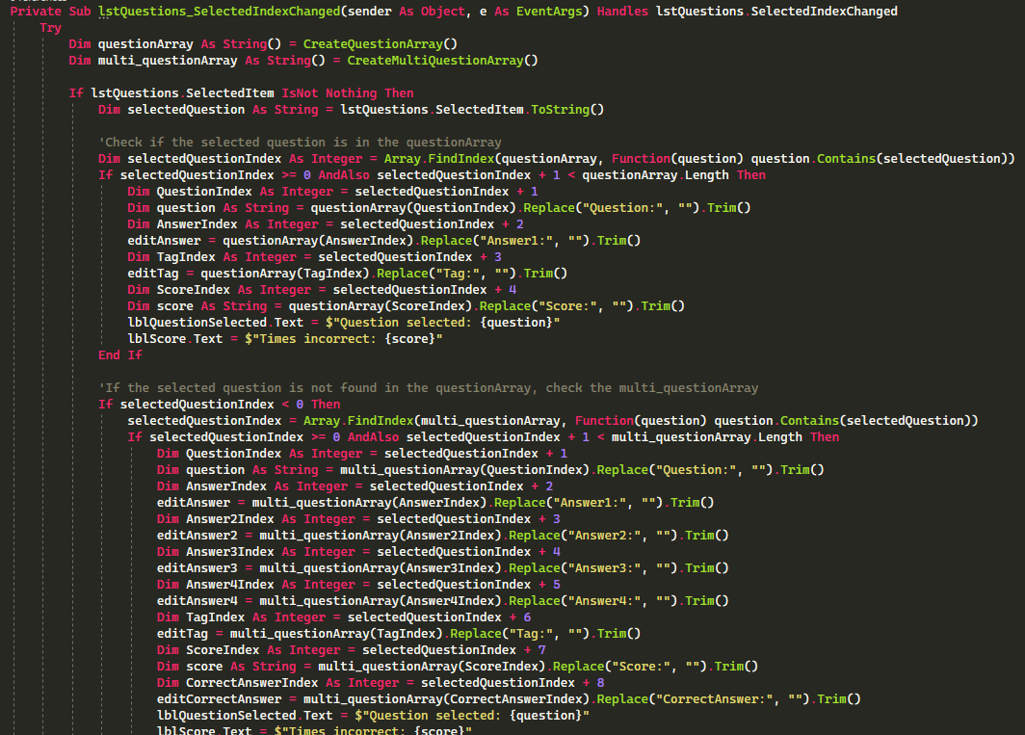

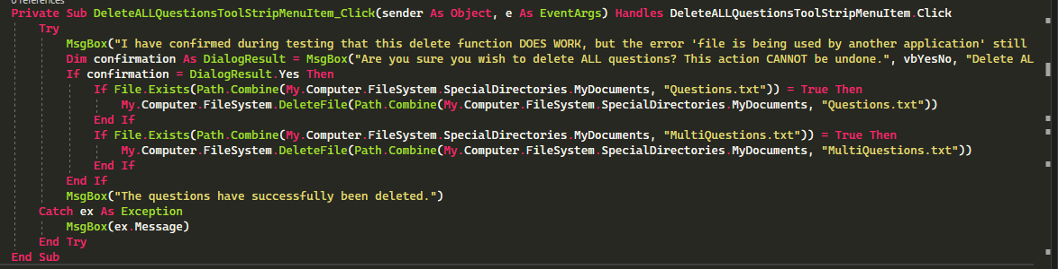

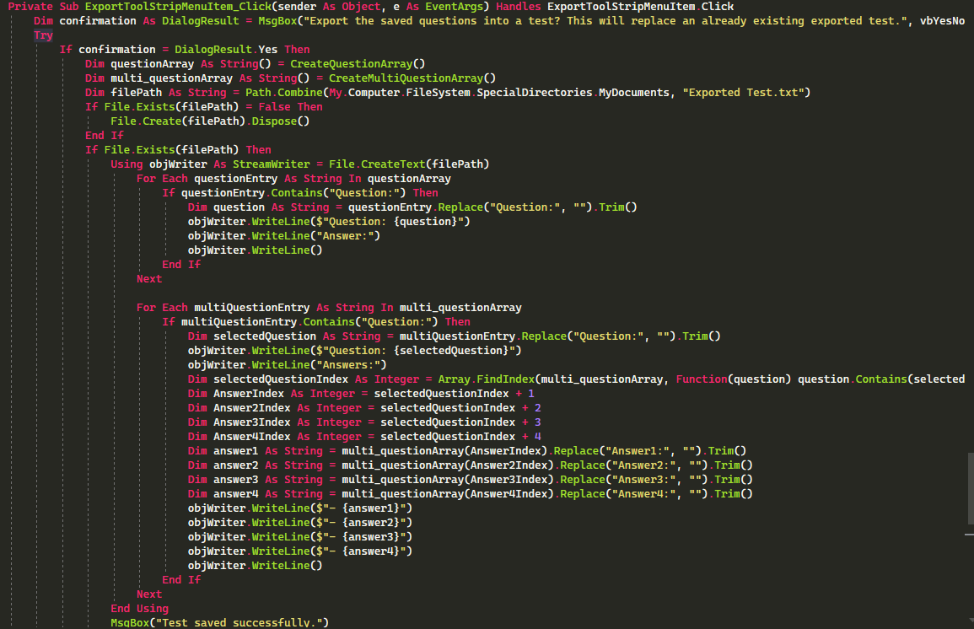

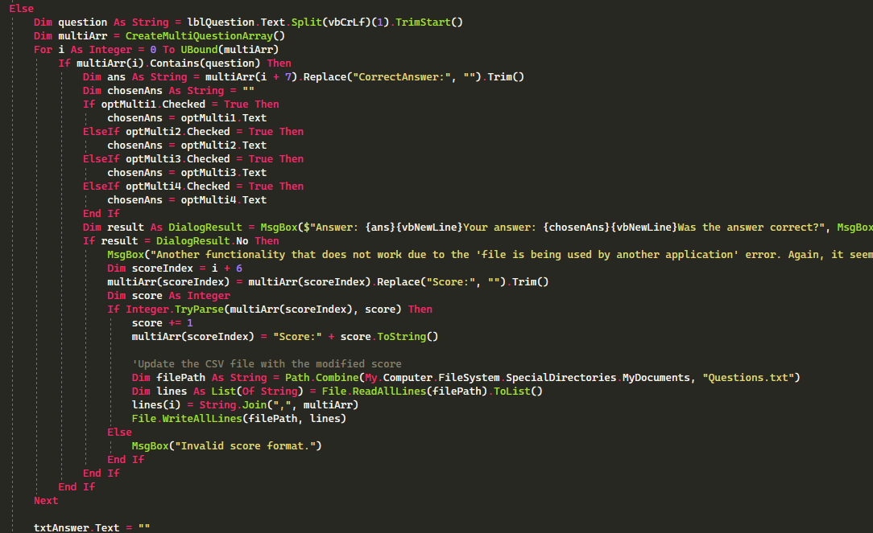

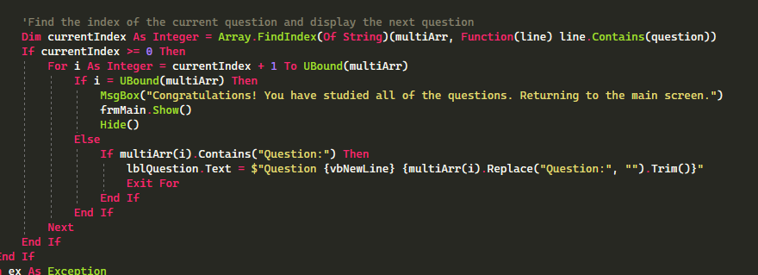

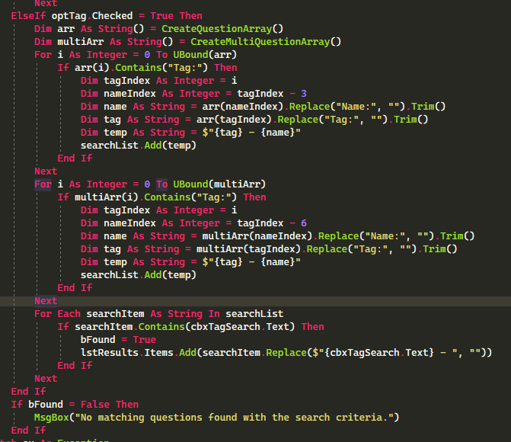

**18/06**

Internal documentation for the solution as well as the write up for the modifications and justifications were completed.



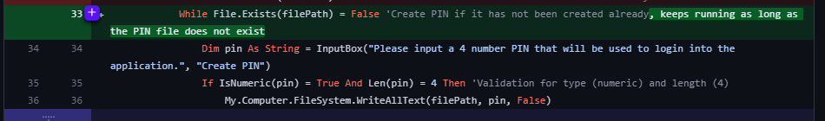

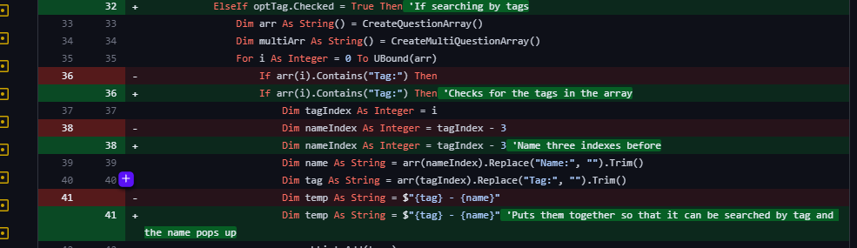

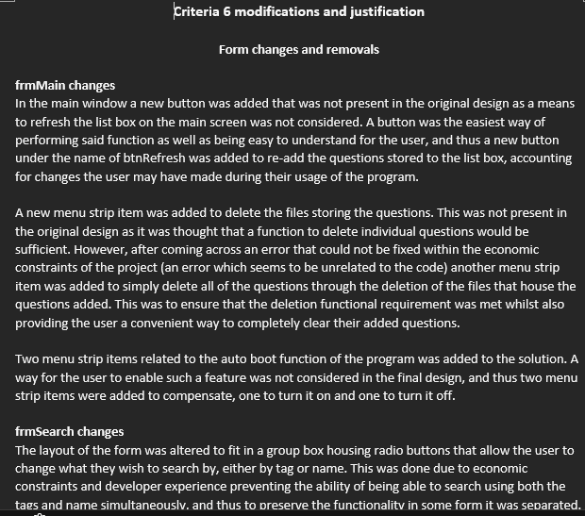

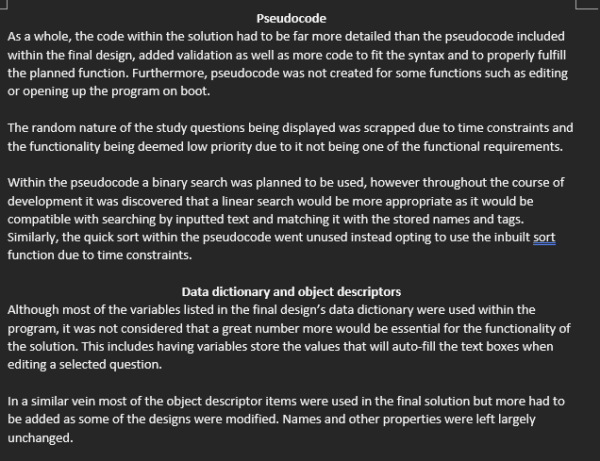

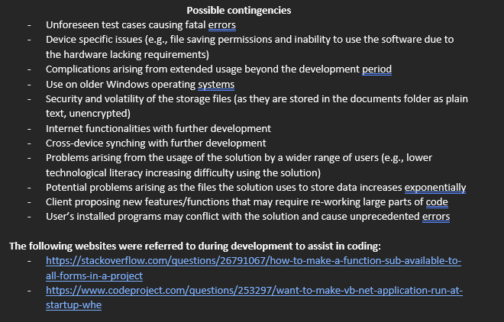

**19/06**

The write up for the security portion of criteria 7 was completed in class today. The next class will be spent writing up justification for the data structures used in the solution.

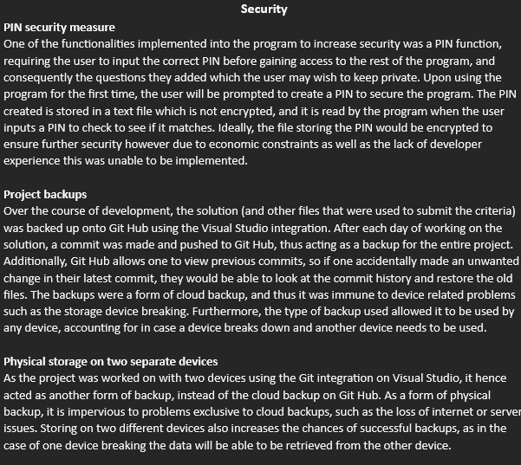

**20/06**

The write up for the data structures justification was completed.

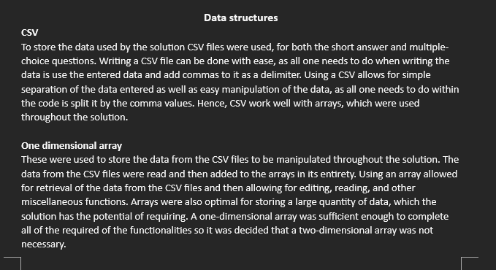

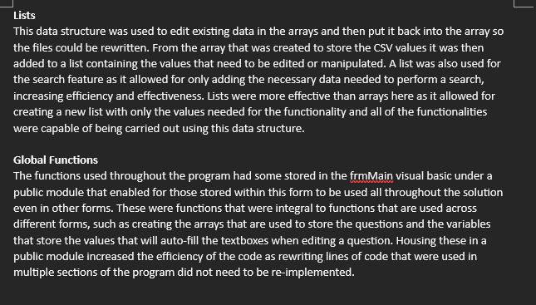

**22/06**

In class - work on the testing table was started. The testing table for frmLogin is mostly complete.

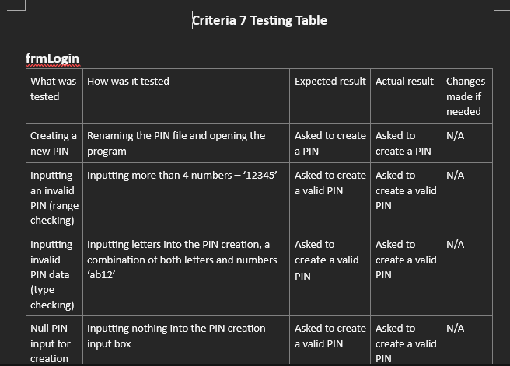

Out of class - the testing table is mostly complete and some bug fixes were made.

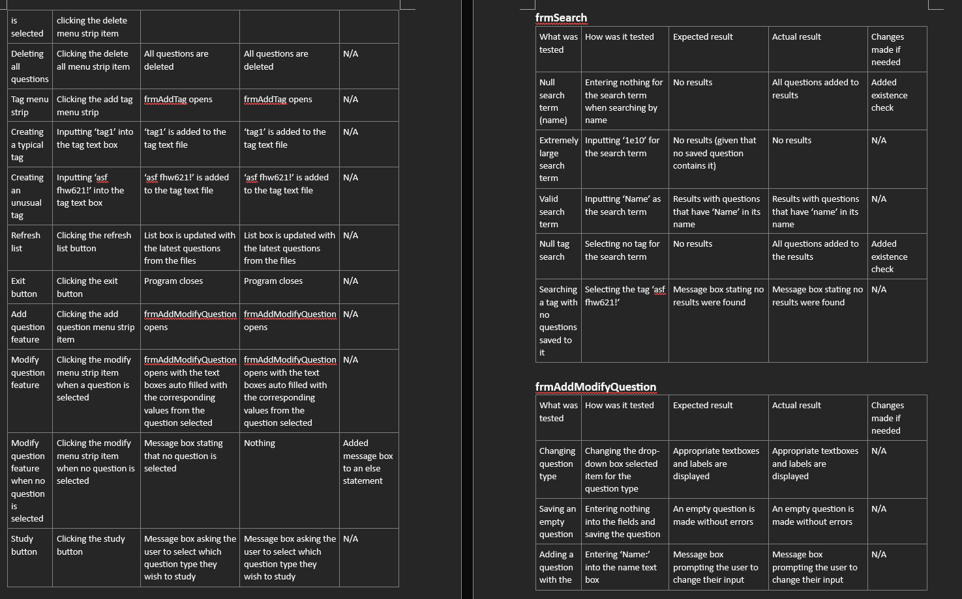

**23/06**

The testing table was completed with a few more entries added.

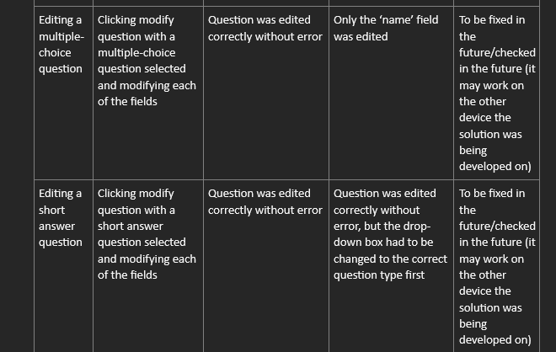

**10/07**

The usability testing document was created with some entries for the test cases made.

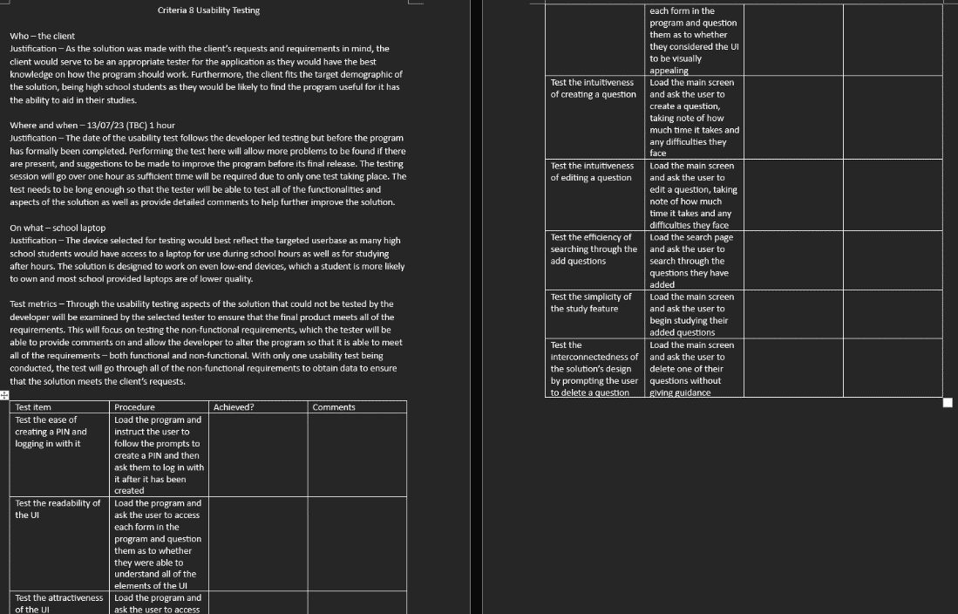

**11/07**

The testing table for the usability testing document was completed. The testing session will soon follow.

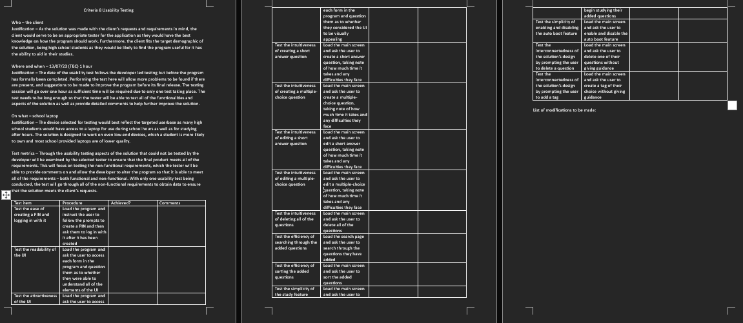

**12/07**

The testing by the client was completed out of school hours.

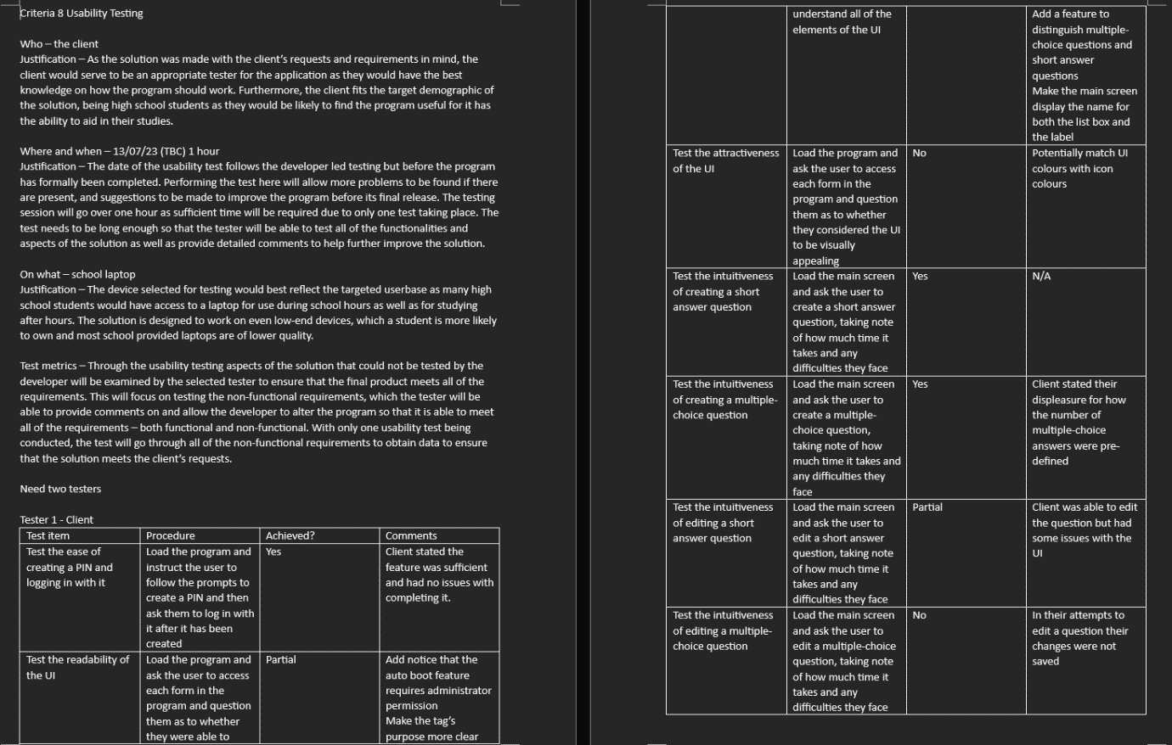

**13/07**

The second tester completed the testing of the program and their results were recorded. Later the modifications that will be made will be written up and some will be applied to the program, the ones able to be completed within the limited timeframe.

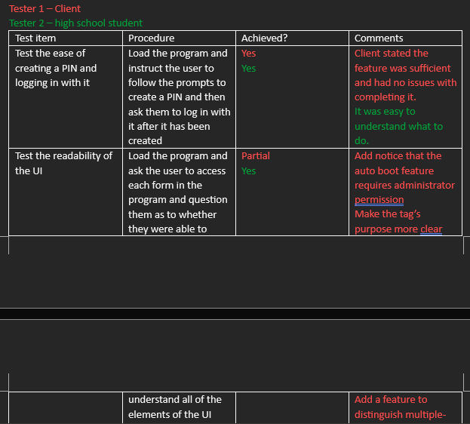

**14/07**

Criteria 8 was completed with a modification to the auto boot feature made to make it easier to add the exe's path for it to have the feature enabled.

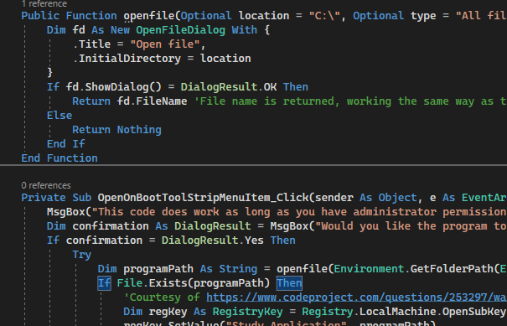

**17/07**

Criteria 9 was started with the evaluation table started.

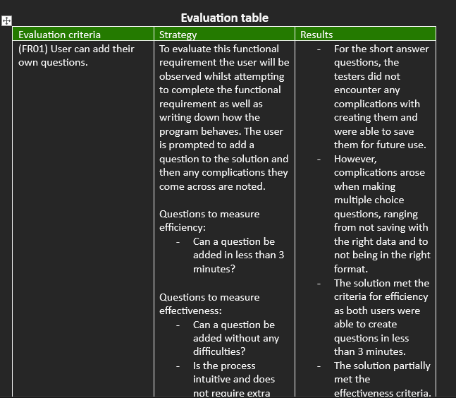

In light of missing a class the next day due to a student free day work outside of school hours was done to complete the evaluation table.

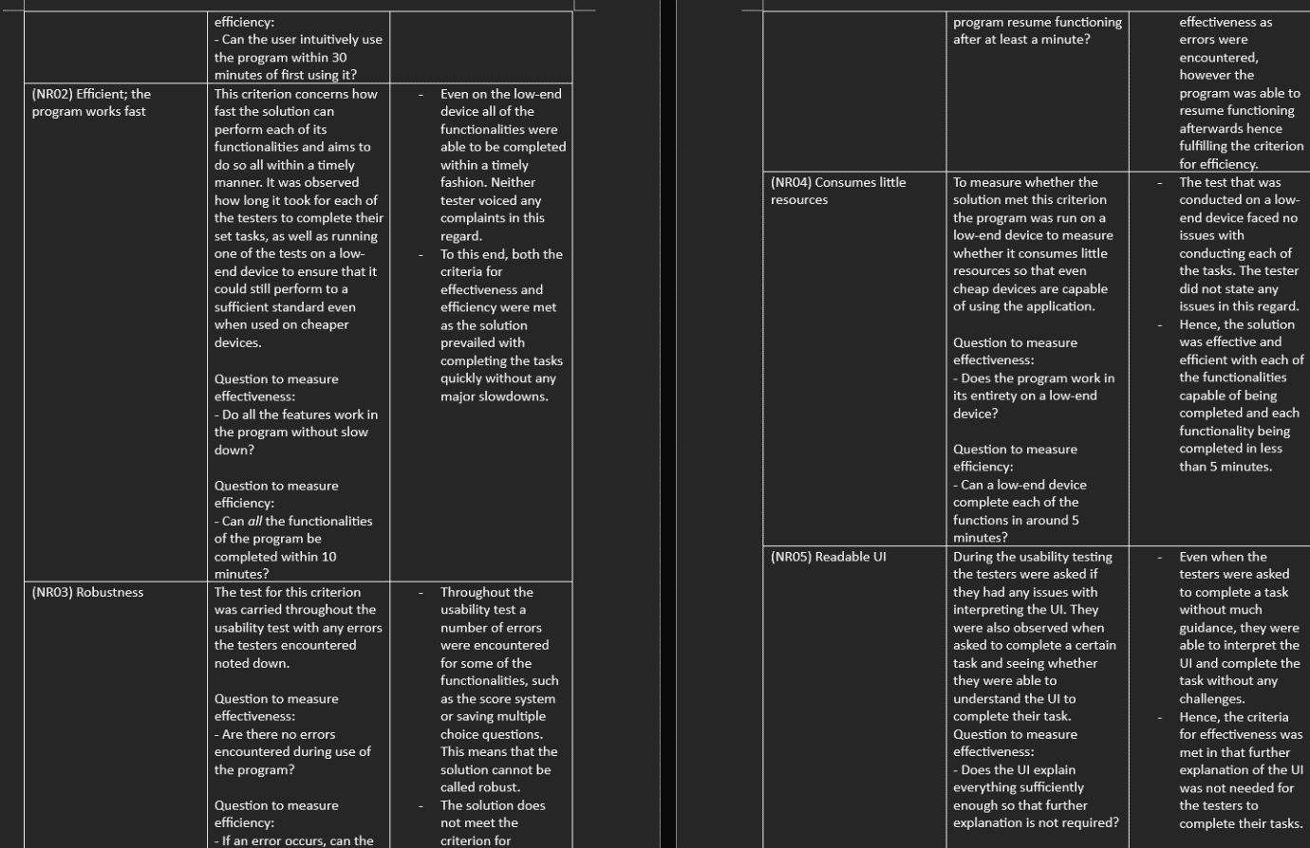

**20/07**

The conclusion of the evaluation was completed and the write up on the development model evaluation was mostly completed.

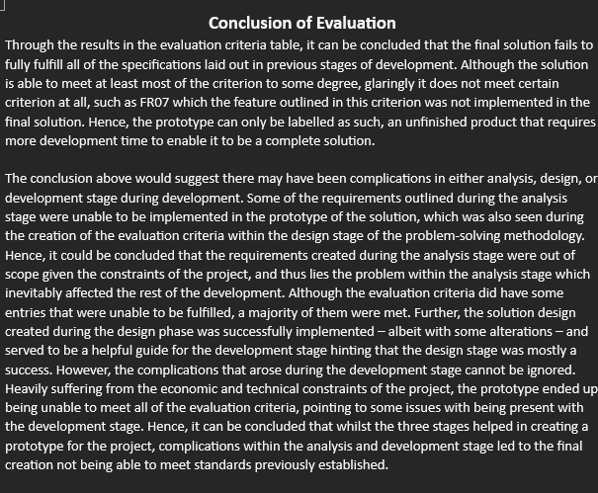

**21/07**

Slight edits were made to the evaluation report and it was submitted.

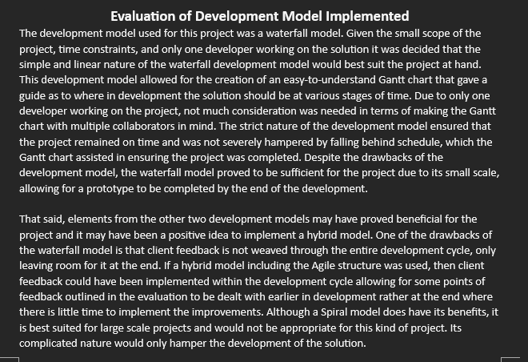

**24/07**

The write up for criteria 10 was commenced.

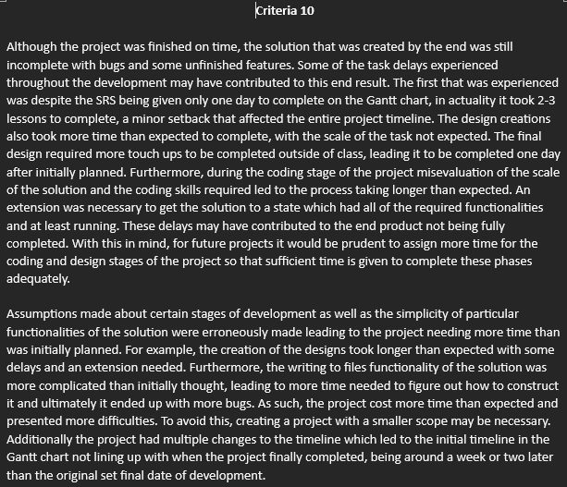

**25/07**

The evaluation of the Gantt chart was completed, only the last three dot points on the notes page remains.

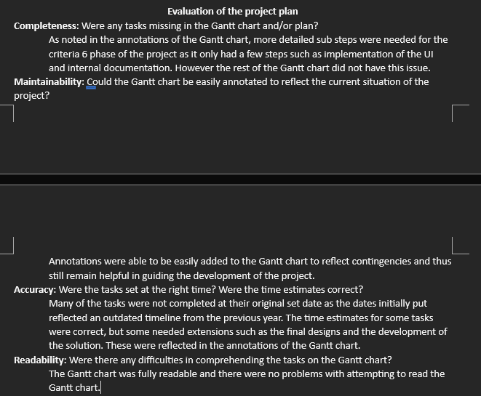

**27/07**

The write up for criteria 10 was completed with the conclusion being written up in the period. Next lesson it will be submitted, perhaps with some slight edits.

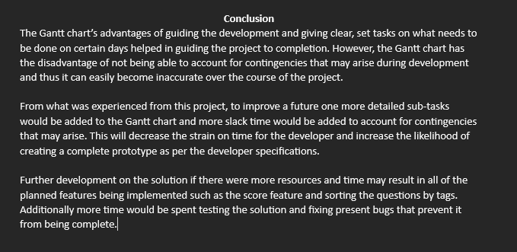

**28/07**

Criteria 10 was finalised with images of the Gantt chart put in as well as the logbook that was created throughout the project.

